**The University of Texas at Dallas**

**Department of Computer Science**

**CS 6360.003 Database Design**

**UTD FreshMart e-commerce System Report**

**Report Instructor – Dr. Jalal Omer 05/01/2023**

**Team :**

**Hanumath Sai Abhilash Babu Veluvali - HXV220011**

**Sanjana Gombi - SXG210274**

**Vrushali Purushottam Gajare - VXG220058**

**Sai Vinay Reddy Chillakuru - SXC220124**

**Savyasachi Kokkirala - SXK220272**

**Kavya Nandigam - KXN220024**

**Table of Contents**

I. Introduction 3

II. System Requirements 4

III. Design of the Database 7

IV. Database Schema 8

V. Functional Dependencies and Database Normalization 13

VI. The Database System 15

VII. Additional Queries and Views 46

VIII. User application interface 48

IX. Conclusions and Future Work 51

X. References 52

XI. Appendix 52

### 

### **Introduction**

The primary purpose of an e-commerce platform is to provide a venue for the marketing and delivery of goods, services, and other items through the internet and other networks. The goal of this project is to create an online store for UTD FreshMart, a retailer of groceries such fruits, vegetables, snacks, and other home goods. Customers are given access to a shopping cart to which they may put the items they wish to purchase in order to make online purchases easier.

Each of the three user types—Admin, Customer, and Vendor—has a separate set of features.

The administrator's duties include managing vendors, approving return requests, and creating, editing, and deleting users. Additionally, the administrator handles the UTD FreshMart's general operation and transaction monitoring. Customers can purchase any goods and submit a return request if the item is defective or there is another problem. Vendors can add the products they wish to sell and process the order.

In order to make a payment and produce an invoice, the application will allow users to register and fill out their bank information. The UTD FreshMart is open seven days a week, twenty-four hours a day.

The front-end application will be connected to using a JDBC connection, and the application will use the MySQL DBMS. CSS and HTML will be used to build the front-end.

### **System Requirements**

Functional requirements (user's operational concepts)

**Login Functional Requirements:**

1: The system will allow the user to log in.

2. The system will verify the username and password.

3. The system will not allow the user to log in with an invalid username or password.

4. The system will be able to remember usernames and passwords.

5. The system will allow users to create accounts.

6. The system will enable users to log out of their accounts

**Browser Functional Requirements:**

**System:**

1. When a page fails to load, we display error 404 (check)
2. Load and Display Web pages in minimal time
3. Store login details in cache till they logout
4. Alert (popup) for incorrect login credentials.

**Customer:**

1. Customer can add products to the cart.
2. Customer can remove products from the cart.
3. Customer can view the product description.
4. Customer can return the product in case of product damaged by using WhatsApp support.
5. A returning customer can login from the login page.
6. A new customer can sign up using phone number/email.
7. A customer can check out as a guest using phone number as a primary key.
8. Customer can add the products to the wish list.
9. Customer can add the product from wish list to the cart individually or all at once.

**Vendor:**

1. Home page which displays the products within the inventory.
2. Vendor Personal Information Page: This should contain all the personal details of the vendor (No. of products, qty of each product, price of each product and description of each product)
3. **Filter:** Vendor should be able to sort the products by preference and availability.
4. **Remove inventory:** If the vendor plans to remove a product from the inventory, he must be able to do it by clicking the remove stock button which sends a request to admin.
5. **Load Inventory:** If the vendor plans to remove a product from the inventory, he must be able to do it by clicking the remove stock button which sends a request to admin.
6. Vendor can cancel the order when there is a huge demand and lack of inventory.

**Admin Functional Requirements**

1. When a new user requests for the admin with a create account functionality, admin should be able to allow the user to create a new account.
2. When a new vendor registers, the admin can have an access to accept or reject that vendor.
3. Perform authentication and encryption functions.
4. Customer support WhatsApp chat or call.
5. Admin must be able to add inventory to the database.
6. Admin must be able remove the inventory from the database
7. Admin must be able to update the inventory when a purchase has been made.
8. Admin must be able to accept the description change request from the vendor and change the description if it satisfies the checklist.
9. Admin can be able to cancel the vendor's contract if vendor does not satisfies the user's requirement.
10. Admin must be able to revisit the transaction and alter/update the transaction (re-initiate) if there is a payment gateway problem.

d) Non-functional requirements (e.g., response time, maintainability)

1. **Security:** The website should have robust security measures in place to protect sensitive user data, such as passwords and bank account numbers.
2. **Scalability:** The website should be able to scale accordingly with the increasing number of users and products.
3. **Performance:** The website should be fast and responsive, enabling quick access to products and transactions for the users.
4. **User Experience:** The platform should have a simple and user-friendly interface which should be easy to understand and use.
5. **Reliability:** The platform should be reliable and consistent, with minimum downtime.
6. **Integration and accessibility:** The platform should be accessible from different devices, including desktop and mobile devices and should be able to integrate with other third-party system gateways such as payment gateways for seamless transactions.
7. **Data Backup and management:** An efficient and secure backup system should be in place to protect user data and sensitive information and have an efficient data management system in order to maintain the data integrity.
8. **Compliance:** The platform should comply with industry standards and regulations with regards to data privacy and security.
9. **Customization:** The platform should have the ability to be customized to meet specific business requirements.
10. **Technical Support:** The platform should have a technical support system in place to assist users with any technical issues.
11. **Inventory Management:** The platform should have an effective inventory management system in place to ensure that products are available when customers want to purchase them.
12. **User Feedback:** The platform should provide an easy and convenient way for users to provide feedback and suggestions, helping to continuously improve the platform.

### **Design of the Database**

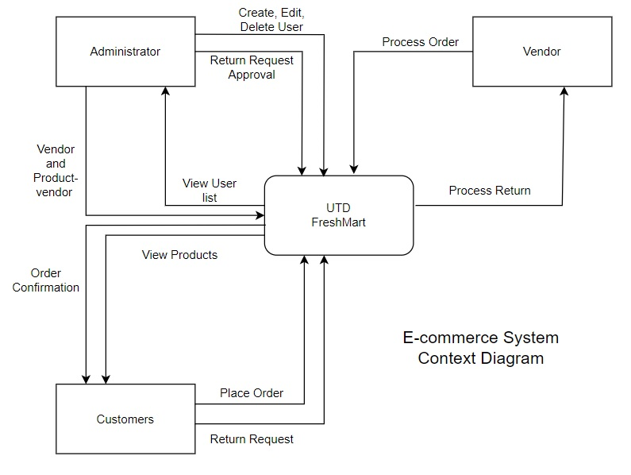

### **Database Schema**

**1.Entity Relationship Diagram :**

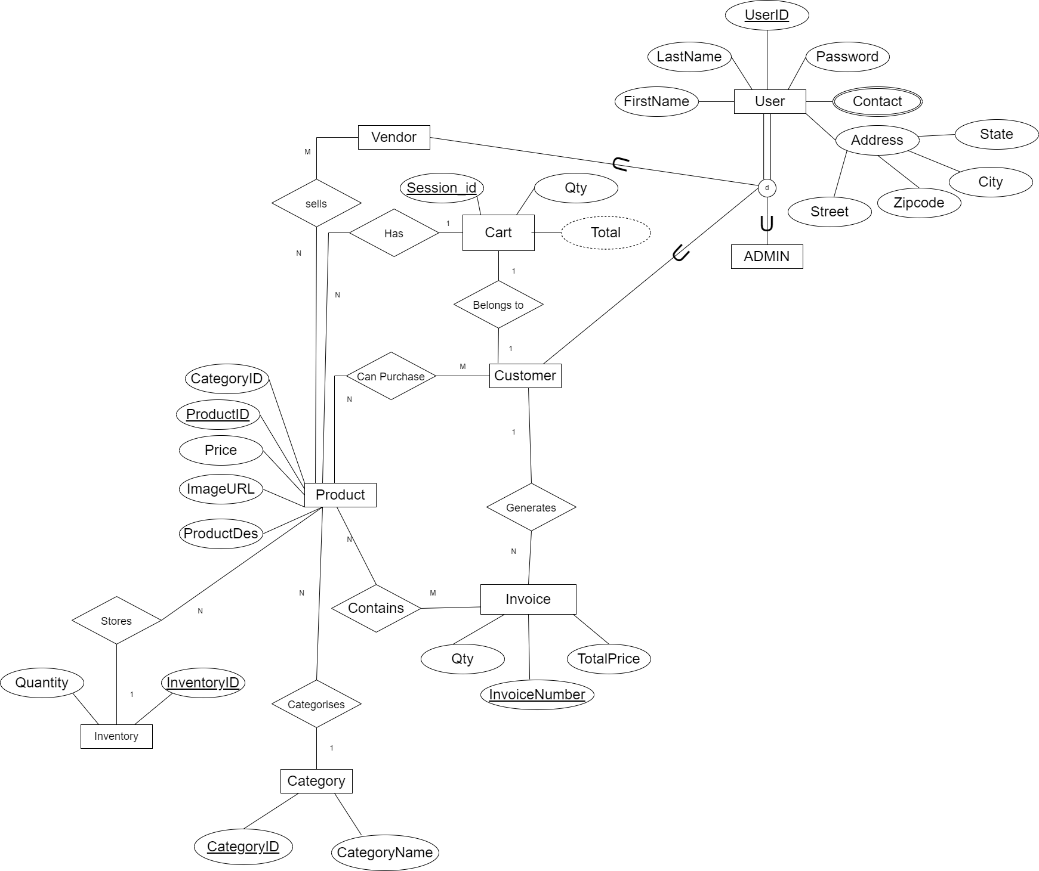

2. **Database Schema**

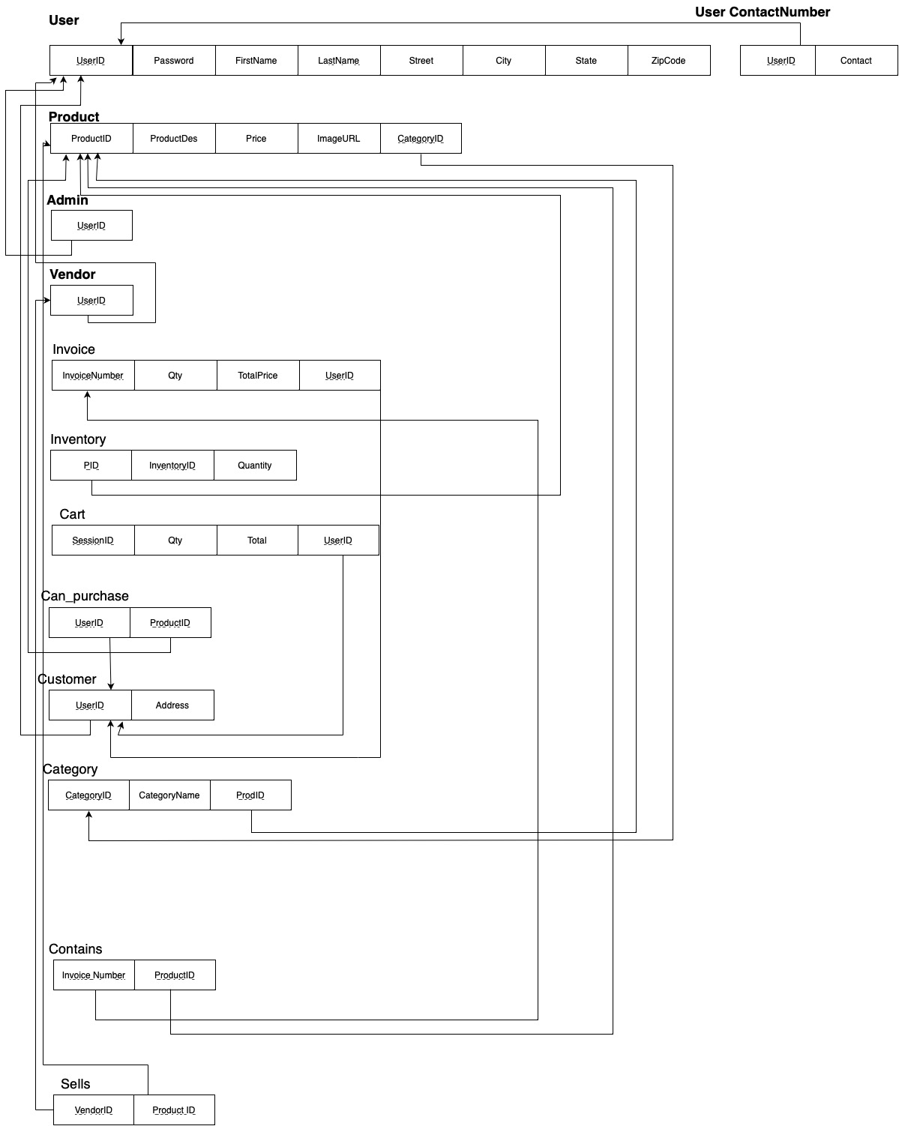

**3.1 Business requirements:**

1. Customers should be able to browse and buy products on the platform.
2. Vendors should be able to manage their inventory and products on the platform.
3. Customers should be able to add items to their cart and wishlist on the platform.
4. Customers should be able to view their transaction history and invoices on the platform.
5. Admins should be able to manage vendors, customers, and inventory on the platform.
6. The platform must guarantee that the customer's contact and address details are correct and current.
7. The platform should make sure that the product information provided by the vendor is accurate and up to date.
8. Platform should make sure that the inventory accurately reflects the number of products that are available.
9. Customers should be able to securely make payments through the platform.
10. Customer data should be secured and protected by the platform.

**3.2 Integrity Constraints:**

1. UserID is the primary key for the super class User. So, UserID is NOT NULL and UNIQUE.
2. UserID is the primary key as well as foreign key (from the superclass User) for the subclasses Customer, Vendor and Admin.
3. ProductID is the primary Key for the entity Product. So, ProductID is UNIQUE and NOT NULL.
4. ProductID is the foreign key for Inventory
5. InvoiceNumber is the primary Key for the entity Invoice. Hence, InvoiceNumber is UNIQUE and NOT NULL.
6. InventoryID is the primary key for the entity Inventory. Hence it is NOT NULL and UNIQUE.
7. Session ID is the primary key for Cart Entity. Session ID is UNIQUE for each customer login operation and is NOT NULL.
8. Category ID is a primary key for Categories entity. A UNIQUE category ID categorizes products and ID is NOT NULL
9. Can purchase relationship can be uniquely identified using UserID and ProducID keys
10. Invoice relationship with product can be uniquely identified using Invoice number and ProductID.
11. User ID here is a valid email address provided by the User
12. Admin performs the updation of any data related to Products
13. Admin performs the updation of customer and vendor data
14. ‘Total’ attribute in Cart is a derived attribute whose value is dynamically calculated

**4. User Interfaces:**

1. User-Friendly environment: The user interface is simple to operate and navigate. This includes features like clear labeling of fields, intuitive forms, and easy-to-understand instructions.
2. Search Bar: When a user types the first three letters of a product or category in the search bar, a list of all matching goods and categories in our database is displayed
3. No products will be shown when several random keywords are entered throughout the search process. We firmly advise the client to try again.
4. Cart: Every user has a unique cart that they may change when they check in to the website and can be used to view any earlier saved items.
5. Each item in the search list can be clicked to access a more detailed product page, from which we can either add the item to our basket or go to the checkout.
6. The user can browse forward or backward through the website by clicking the proper buttons.
7. Wishlist: While a consumer is viewing a certain product, a Wishlist option will be available on the main page and beside each item. A product that a consumer likes will be put to their Wishlist.
8. Users must enter data using a consistent format according to the interface's requirements to maintain data quality and consistency. Drop-down menus, check boxes, and other methods of data validation can be used to do this.
9. Security necessary requirements: The interface offers sufficient security precautions to safeguard sensitive data. Access control and user authentication are two examples of this.
10. Authentication: Websites should mandate that users generate strong, challenging-to-guess passwords, and encourage them to routinely change their passwords.
11. Access control : Users must be authorized in order to login: The only way to access the website is by logging in or using a valid login. If an administrator logs in, he can only execute administrative tasks and not those for customers or retailers.
12. Sensitive information should be protected by suitable access controls and encryption procedures, which should be in place when entering data.
13. Several simultaneous logins are not regarded as secure. By repeatedly requesting CVV and extra access codes, online payments are processed securely.
14. Profile Management: Profile Icon will be offered on the main page where the users will have access to their purchase history, updating their personal details, updating the passwords.

Platform Independent: All devices should be able to view the website.

### **Functional Dependencies and Database Normalization**

**1.Functional dependencies and Normalization process :**

**1.1 UserID:**

**FD1** { UserID -> Password, FirstName, LastName, Street, City, State, ZipCode}

**FD2** {ZipCode -> City}

UserID determines Password, FirstName, LastName, Street, City, State, ZipCode.

ZipCode determines City

Since FD1 and FD2 violate 3NF, Normalization is required and new tables are made.

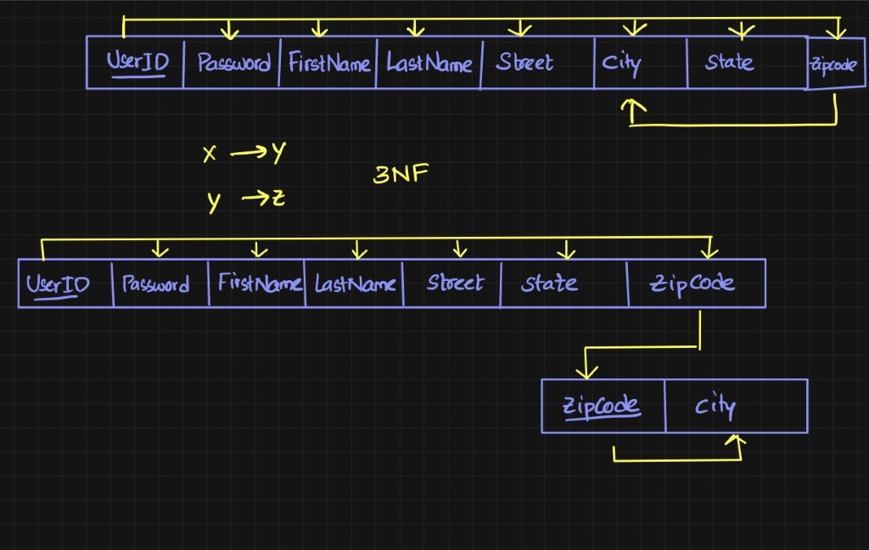

UserID table is split into UserID and ZipCity tables

**UserID**

UserID Password, FirstName, LastName, Street, State, ZipCode.

**ZipCity**

ZipCode, City

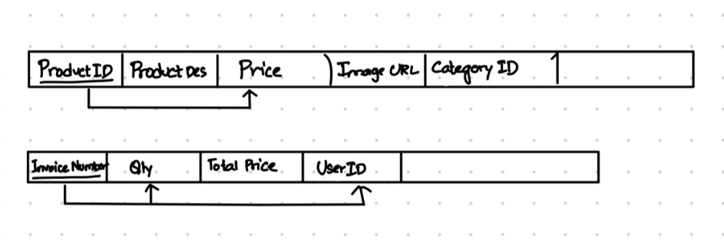

**1.2: Product**

**FD1 { ProductID ->** ProductDescription, Price, ImageURL, CategoryID }

productID determines ProductDescription, Price, ImageURL, CategoryID

**1.3 Invoice**

**FD1 { InvoiceNumber ->** Qty, TotalPrice, UserID }

Invoice Number determines Qty, TotalPrice, UserID

### **The Database System**

**SQL Statements for Database Construction**

* **Table- ZipCity**

CREATE TABLE ZipCity (

Zipcode VARCHAR(25) NOT NULL,

City VARCHAR(25) NOT NULL,

PRIMARY KEY (Zipcode)

);

**Insert-**

INSERT INTO ZipCity VALUES ('12345','1415 Cedar St'),

('67890','123 Main St'),

('23456','456 Elm St'),

('34567','789 Oak Ave'),

('45678','1011 Pine St'),

('56789','1213 Maple Dr'),

('67891','1617 Spruce St'),

('78901','1819 Cherry Ln'),

('89012','2021 Birch Rd'),

('90123','2223 Oak Dr'),

('01234','2425 Maple Ave');

* **Table- User**

CREATE TABLE User (

UserID VARCHAR(25) NOT NULL,

Password VARCHAR(100) NOT NULL,

FirstName VARCHAR(100) NOT NULL,

LastName VARCHAR(100) NOT NULL,

Street VARCHAR(100) NOT NULL,

State VARCHAR(100) NOT NULL,

Zipcode VARCHAR(25) NOT NULL,

PRIMARY KEY (UserID),

FOREIGN KEY (Zipcode) REFERENCES ZipCity(Zipcode) ON DELETE CASCADE ON UPDATE CASCADE

);

**Assertion-**

This assertion determines whether there are any rows in the User table that are adjacent and share the same zipcode but have distinct states. If there are, an error will be raised, showing that the FD zipcode -> state condition has not been met.

CREATE ASSERTION "ZIPST" CHECK (

NOT EXISTS (

SELECT *

FROM User u1

JOIN User u2

ON u1.userId = u2.userId

Where u1.zipcode = u2.zipcode AND u1.city < > u2.city

)

);

**Insert-**

INSERT INTO User (UserID, Password, FirstName,LastName, Street, State, Zipcode) VALUES

('C1', 'password1', 'John', 'Doe', '123 Main St', 'CA', '12345'),

('C2', 'password2', 'Jane', 'Smith', '456 Elm St', 'NY', '67890'),

('C3', 'password3', 'Bob', 'Johnson', '789 Oak Ave', 'FL', '23456'),

('C4', 'password4', 'Alice', 'Lee', '1011 Pine St', 'TX', '34567'),

('C5', 'password5', 'David', 'Garcia', '1213 Maple Dr', 'IL', '45678'),

('A1', 'password6', 'Maria', 'Hernandez', '1415 Cedar St', 'WA', '56789'),

('V1', 'password7', 'Chris', 'Anderson', '1617 Spruce St', 'OH', '67891'),

('V2', 'password8', 'Jessica', 'Brown', '1819 Cherry Ln', 'PA', '78901'),

('V3', 'password9', 'Michael', 'Wilson', '2021 Birch Rd', 'NC', '89012'),

('V4', 'password10', 'Michelle', 'Davis', '2223 Oak Dr', 'AZ', '90123'),

('V5', 'password11', 'Brian', 'Martinez', '2425 Maple Ave', 'NJ', '01234');

* **Table- User_ContactNumber**

CREATE TABLE User_ContactNumber(

UserID VARCHAR(25) NOT NULL,

Contact VARCHAR(20),

FOREIGN KEY (UserID) REFERENCES User(UserID) ON DELETE CASCADE ON UPDATE CASCADE

);

**Insert-**

INSERT INTO User_ContactNumber (UserID, Contact) VALUES ('C1', '1234567890');

INSERT INTO User_ContactNumber (UserID, Contact) VALUES ('C2', '9876543210');

INSERT INTO User_ContactNumber (UserID, Contact) VALUES ('C3', '5555555555');

INSERT INTO User_ContactNumber (UserID, Contact) VALUES ('C4', '9998887777');

INSERT INTO User_ContactNumber (UserID, Contact) VALUES ('C5', '1112223333');

INSERT INTO User_ContactNumber (UserID, Contact) VALUES ('A1', '4445556666');

INSERT INTO User_ContactNumber (UserID, Contact) VALUES ('V1', '7777777777');

INSERT INTO User_ContactNumber (UserID, Contact) VALUES ('V2', '8888888888');

INSERT INTO User_ContactNumber (UserID, Contact) VALUES ('V3', '5551112222');

INSERT INTO User_ContactNumber (UserID, Contact) VALUES ('V4', '4444444444');

INSERT INTO User_ContactNumber (UserID, Contact) VALUES ('V5', '1111111111');

* **Table- Product**

CREATE TABLE Product (

ProductID VARCHAR(25) NOT NULL,

ProductDes VARCHAR(100) NOT NULL,

Price DECIMAL(10,2) NOT NULL,

ImageURL VARCHAR(100) NOT NULL,

PRIMARY KEY (ProductID)

);

**Assertion-**

The Product table is searched for any sets of rows where the Productid is the same but the price is different. If there are, an error will be raised, showing that the FD Productid -> price condition is not met.

CREATE ASSERTION "PIDPRICE" CHECK (

NOT EXISTS (

SELECT *

FROM Product p1

JOIN Product p2

ON p1.ProductID =p2.ProductID

WHERE p1.Productid = p2.Productid AND p1.price < > p2.price

)

);

**Insert-**

INSERT INTO Product (ProductID, ProductDes, Price, ImageURL)

VALUES ('P1001', 'Apple', 0.99, 'https://example.com/apple.jpg');

INSERT INTO Product (ProductID, ProductDes, Price, ImageURL)

VALUES ('P1002', 'Orange', 1.50, 'https://example.com/orange.jpg');

INSERT INTO Product (ProductID, ProductDes, Price, ImageURL)

VALUES ('P1003', 'Broccoli', 2.99, 'https://example.com/broccoli.jpg');

INSERT INTO Product (ProductID, ProductDes, Price, ImageURL)

VALUES ('P1004', 'Carrot', 1.25, 'https://example.com/carrot.jpg');

INSERT INTO Product (ProductID, ProductDes, Price, ImageURL)

VALUES ('P1005', 'Fruit Salad', 4.99, 'https://example.com/fruitsalad.jpg');

INSERT INTO Product (ProductID, ProductDes, Price, ImageURL)

VALUES ('P1006', 'Vegetable Stir Fry', 6.99, 'https://example.com/stirfry.jpg');

INSERT INTO Product (ProductID, ProductDes, Price, ImageURL)

VALUES ('P1007', 'Bell Pepper', 0.99, 'https://example.com/bellpepper.jpg');

INSERT INTO Product (ProductID, ProductDes, Price, ImageURL)

VALUES ('P1008', 'Green Apple', 1.50, 'https://example.com/greenapple.jpg');

INSERT INTO Product (ProductID, ProductDes, Price, ImageURL)

VALUES ('P1009', 'Capsicum', 2.99, 'https://example.com/broccoli.jpg');

INSERT INTO Product (ProductID, ProductDes, Price, ImageURL)

VALUES ('P1010', 'Okra', 1.25, 'https://example.com/okra.jpg');

INSERT INTO Product (ProductID, ProductDes, Price, ImageURL)

VALUES ('P10011', 'Fruit Sundae', 4.99, 'https://example.com/fruitsundae.jpg');

INSERT INTO Product (ProductID, ProductDes, Price, ImageURL)

VALUES ('P10012', 'Vegetable Sundae', 6.99, 'https://example.com/stirf12ry.jpg');

* **Table- Admin**

CREATE TABLE Admin (

UserID VARCHAR(25) NOT NULL PRIMARY KEY,

FOREIGN KEY (UserID) REFERENCES User(UserID) ON DELETE CASCADE ON UPDATE CASCADE

);

**Insert**-

INSERT INTO Admin (UserID)

VALUES ('A1');

* **Table- Vendor**

CREATE TABLE Vendor (

UserID VARCHAR(25) NOT NULL PRIMARY KEY,

FOREIGN KEY (UserID) REFERENCES User(UserID) ON UPDATE CASCADE ON DELETE CASCADE

);

**Insert**-

INSERT INTO Vendor (UserID)

VALUES ('V1'), ('V2'), ('V3'), ('V4'), ('V5');

* **Table- Customer**

CREATE TABLE Customer (

UserID VARCHAR(25) NOT NULL PRIMARY KEY,

Address VARCHAR(100) NOT NULL,

FOREIGN KEY (UserID) REFERENCES User(UserID) ON UPDATE CASCADE ON DELETE CASCADE

);

**Insert**-

INSERT INTO Customer (UserID, Address) VALUES ('C1', '123 Main St');

INSERT INTO Customer (UserID, Address) VALUES ('C2', '456 Oak St');

INSERT INTO Customer (UserID, Address) VALUES ('C3', '789 Elm St');

INSERT INTO Customer (UserID, Address) VALUES ('C4', '1010 Pine St');

INSERT INTO Customer (UserID, Address) VALUES ('C5', '1212 Maple St');

* **Table- Invoice**

CREATE TABLE Invoice (

InvoiceNumber INT NOT NULL,

Qty INT NOT NULL,

TotalPrice DECIMAL(10, 2) NOT NULL,

UserID VARCHAR(25) NOT NULL,

PRIMARY KEY (InvoiceNumber),

FOREIGN KEY (UserID) REFERENCES Customer(UserID) ON UPDATE CASCADE ON DELETE CASCADE

);

**Assertion-**

1. This assertion checks if there are any pairs of rows in the Invoice table where the InvoiceNumber is the same but the Qty is different. If there are, the assertion will raise an error, indicating that the FD InvoiceNumber -> Qty is not satisfied.

CREATE ASSERTION "INVQTY" CHECK (

NOT EXISTS (

SELECT 1

FROM Invoice i1

JOIN Invoice i2

ON i1.InvoiceNumber = i2.InvoiceNumber

WHERE i1.invoicenumber = i2.invoicenumber AND i1.qty < > i2.qty AND i1.userid < > i2.userid

)

);

**Insert-**

INSERT INTO Invoice (InvoiceNumber, Qty, TotalPrice, UserID) VALUES (10011, 2, 49.99, 'C1');

INSERT INTO Invoice (InvoiceNumber, Qty, TotalPrice, UserID) VALUES (10021, 3, 69.99, 'C2');

INSERT INTO Invoice (InvoiceNumber, Qty, TotalPrice, UserID) VALUES (10031, 1, 19.99, 'C3');

INSERT INTO Invoice (InvoiceNumber, Qty, TotalPrice, UserID) VALUES (10041, 5, 129.99, 'C4');

INSERT INTO Invoice (InvoiceNumber, Qty, TotalPrice, UserID) VALUES (10051, 2, 39.99, 'C5');

* **Table- Inventory**

CREATE TABLE Inventory (

InventoryID INT NOT NULL,

Quantity INT NOT NULL,

PID VARCHAR(25) NOT NULL,

PRIMARY KEY (InventoryID),

FOREIGN KEY (PID) REFERENCES Product(ProductID) ON UPDATE CASCADE ON DELETE CASCADE );

**Insert-**

INSERT INTO Inventory (InventoryID, Quantity, PID) VALUES (101, 10, 'P1001');

INSERT INTO Inventory (InventoryID, Quantity, PID) VALUES (102, 20, 'P1002');

INSERT INTO Inventory (InventoryID, Quantity, PID) VALUES (103, 30, 'P1003');

INSERT INTO Inventory (InventoryID, Quantity, PID) VALUES (104, 15, 'P1004');

INSERT INTO Inventory (InventoryID, Quantity, PID) VALUES (105, 25, 'P1005');

INSERT INTO Inventory (InventoryID, Quantity, PID) VALUES (106, 8, 'P1006');

INSERT INTO Inventory (InventoryID, Quantity, PID) VALUES (107, 12, 'P1007');

INSERT INTO Inventory (InventoryID, Quantity, PID) VALUES (108, 18, 'P1008');

INSERT INTO Inventory (InventoryID, Quantity, PID) VALUES (109, 5, 'P1009');

INSERT INTO Inventory (InventoryID, Quantity, PID) VALUES (110, 22, 'P1010');

INSERT INTO Inventory (InventoryID, Quantity, PID) VALUES (111, 14, 'P10011');

INSERT INTO Inventory (InventoryID, Quantity, PID) VALUES (112, 6, 'P10012');

* **Table- Cart**

CREATE TABLE Cart (

SessionID INT NOT NULL,

Qty INT NOT NULL,

Total DECIMAL(10, 2) NOT NULL,

UserID VARCHAR(25) NOT NULL,

PRIMARY KEY (SessionID),

FOREIGN KEY (UserID) REFERENCES Customer(UserID) ON UPDATE CASCADE ON DELETE CASCADE

);

**Insert-**

INSERT INTO Cart (SessionID, Qty, Total, UserID) VALUES (101, 2, 199.98, 'C1');

INSERT INTO Cart (SessionID, Qty, Total, UserID) VALUES (102, 1, 899.99, 'C2');

INSERT INTO Cart (SessionID, Qty, Total, UserID) VALUES (103, 3, 2399.97, 'C3');

INSERT INTO Cart (SessionID, Qty, Total, UserID) VALUES (104, 1, 799.99, 'C4');

INSERT INTO Cart (SessionID, Qty, Total, UserID) VALUES (105, 2, 2999.98, 'C5');

* **Table- Category**

CREATE TABLE Category (

CategoryID VARCHAR(25) NOT NULL,

CategoryName VARCHAR(50) NOT NULL,

PRIMARY KEY (CategoryID)

);

**Insert-**

INSERT INTO Category (CategoryID, CategoryName) VALUES ('C001', 'Fruits');

INSERT INTO Category (CategoryID, CategoryName) VALUES ('C002', 'Vegetables');

INSERT INTO Category (CategoryID, CategoryName) VALUES ('C003', 'Sundaes');

* **Table- Can_Purchase**

CREATE TABLE Can_Purchase (

UserID VARCHAR(25) NOT NULL,

ProductID VARCHAR(25) NOT NULL,

PRIMARY KEY (UserID, ProductID),

FOREIGN KEY (UserID) REFERENCES Customer(UserID) ON UPDATE CASCADE ON DELETE CASCADE,

FOREIGN KEY (ProductID) REFERENCES Product(ProductID) ON UPDATE CASCADE ON DELETE CASCADE

);

**Insert-**

INSERT INTO Can_Purchase (UserID, ProductID) VALUES ('C1', 'P1001');

INSERT INTO Can_Purchase (UserID, ProductID) VALUES ('C2', 'P1002');

INSERT INTO Can_Purchase (UserID, ProductID) VALUES ('C3', 'P1003');

INSERT INTO Can_Purchase (UserID, ProductID) VALUES ('C4', 'P1004');

INSERT INTO Can_Purchase (UserID, ProductID) VALUES ('C5', 'P1005');

INSERT INTO Can_Purchase (UserID, ProductID) VALUES ('C1', 'P1006');

INSERT INTO Can_Purchase (UserID, ProductID) VALUES ('C3', 'P1007');

INSERT INTO Can_Purchase (UserID, ProductID) VALUES ('C2', 'P1008');

INSERT INTO Can_Purchase (UserID, ProductID) VALUES ('C4', 'P1009');

INSERT INTO Can_Purchase (UserID, ProductID) VALUES ('C5', 'P1010');

* **Table- Contains**

CREATE TABLE Contains (

InvoiceNumber INT NOT NULL,

ProductID VARCHAR(25) NOT NULL,

PRIMARY KEY (InvoiceNumber, ProductID),

FOREIGN KEY (InvoiceNumber) REFERENCES Invoice(InvoiceNumber) ON UPDATE CASCADE ON DELETE CASCADE,

FOREIGN KEY (ProductID) REFERENCES Product(ProductID) ON UPDATE CASCADE ON DELETE CASCADE

);

**Insert-**

INSERT INTO Contains (InvoiceNumber, ProductID) VALUES (10011, 'P1001');

INSERT INTO Contains (InvoiceNumber, ProductID) VALUES (10011, 'P1006');

INSERT INTO Contains (InvoiceNumber, ProductID) VALUES (10021, 'P1002');

INSERT INTO Contains (InvoiceNumber, ProductID) VALUES (10021, 'P1009');

INSERT INTO Contains (InvoiceNumber, ProductID) VALUES (10031, 'P1003');

INSERT INTO Contains (InvoiceNumber, ProductID) VALUES (10031, 'P1007');

INSERT INTO Contains (InvoiceNumber, ProductID) VALUES (10041, 'P1004');

INSERT INTO Contains (InvoiceNumber, ProductID) VALUES (10041, 'P1009');

INSERT INTO Contains (InvoiceNumber, ProductID) VALUES (10051, 'P1005');

INSERT INTO Contains (InvoiceNumber, ProductID) VALUES (10051, 'P1010');

* **Table- Sells**

CREATE TABLE Sells (

VendorID VARCHAR(25) NOT NULL,

ProductID VARCHAR(25) NOT NULL,

PRIMARY KEY (VendorID, ProductID),

FOREIGN KEY (VendorID) REFERENCES Vendor(UserID) ON UPDATE CASCADE ON DELETE CASCADE,

FOREIGN KEY (ProductID) REFERENCES Product(ProductID) ON UPDATE CASCADE ON DELETE CASCADE );

**Insert-**

INSERT INTO Sells (VendorID, ProductID) VALUES ('V1', 'P1001');

INSERT INTO Sells (VendorID, ProductID) VALUES ('V2', 'P1002');

INSERT INTO Sells (VendorID, ProductID) VALUES ('V3', 'P1003');

INSERT INTO Sells (VendorID, ProductID) VALUES ('V4', 'P1004');

INSERT INTO Sells (VendorID, ProductID) VALUES ('V5', 'P1005');

INSERT INTO Sells (VendorID, ProductID) VALUES ('V1', 'P1006');

INSERT INTO Sells (VendorID, ProductID) VALUES ('V2', 'P1007');

INSERT INTO Sells (VendorID, ProductID) VALUES ('V3', 'P1008');

INSERT INTO Sells (VendorID, ProductID) VALUES ('V4', 'P1009');

INSERT INTO Sells (VendorID, ProductID) VALUES ('V5', 'P1010');

INSERT INTO Sells (VendorID, ProductID) VALUES ('V3', 'P10011');

INSERT INTO Sells (VendorID, ProductID) VALUES ('V4', 'P10012');

* **Table- Categorize**_**Product**

CREATE TABLE Categorize_Product (

CategoryID VARCHAR(25) NOT NULL,

ProductID VARCHAR(25) NOT NULL,

PRIMARY KEY (CategoryID, ProductID),

FOREIGN KEY (CategoryID) REFERENCES Category(CategoryID) ON UPDATE CASCADE ON DELETE CASCADE,

FOREIGN KEY (ProductID) REFERENCES Product(ProductID) ON UPDATE CASCADE ON DELETE CASCADE

);

**Insert-**

INSERT INTO Categorize_Product (CategoryID, ProdID) VALUES ('C001', 'P1001');

INSERT INTO Categorize_Product (CategoryID, ProdID) VALUES ('C002','P1002');

INSERT INTO Categorize_Product (CategoryID, ProdID) VALUES ('C003', 'P1003');

INSERT INTO Categorize_Product (CategoryID, ProdID) VALUES ('C001', 'P1004');

INSERT INTO Categorize_Product (CategoryID, ProdID) VALUES ('C002', 'P1005');

INSERT INTO Categorize_Product (CategoryID, ProdID) VALUES ('C003', 'P1006');

INSERT INTO Categorize_Product (CategoryID, ProdID) VALUES ('C001', 'P1007');

INSERT INTO Categorize_Product (CategoryID, ProdID) VALUES ('C002', 'P1008');

INSERT INTO Categorize_Product (CategoryID, ProdID) VALUES ('C003', 'P1009');

INSERT INTO Categorize_Product (CategoryID, ProdID) VALUES ('C001', 'P1010');

INSERT INTO Categorize_Product (CategoryID, ProdID) VALUES ('C002', 'P10011');

INSERT INTO Categorize_Product (CategoryID, ProdID) VALUES ('C003', 'P10012');

**Implementation of Tables in Database:**

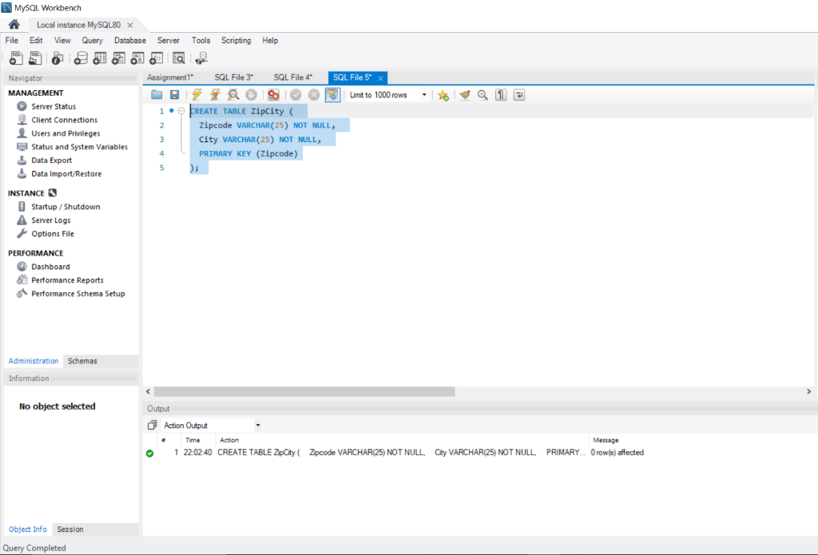

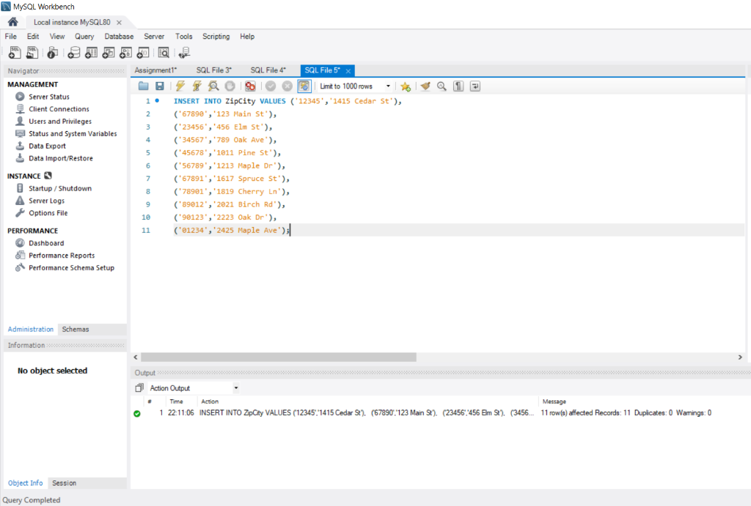

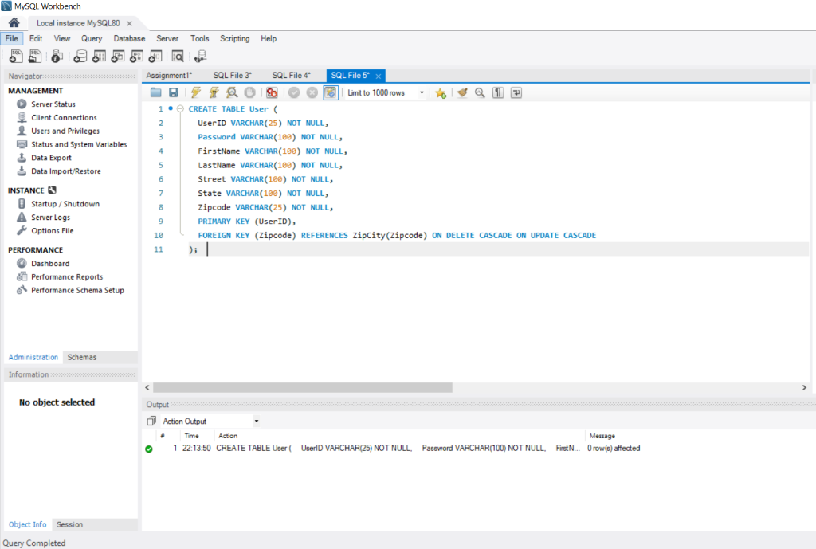

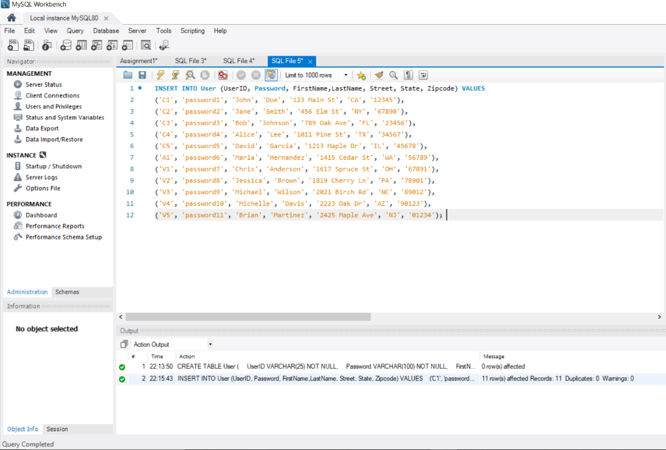

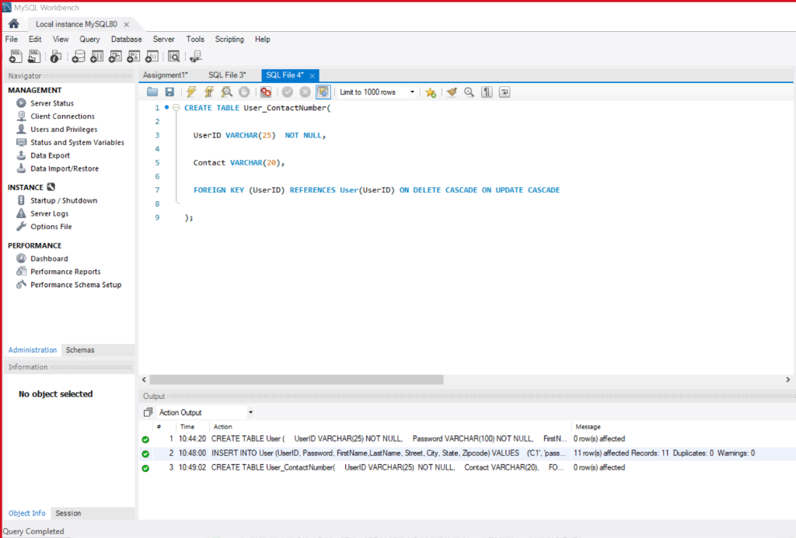

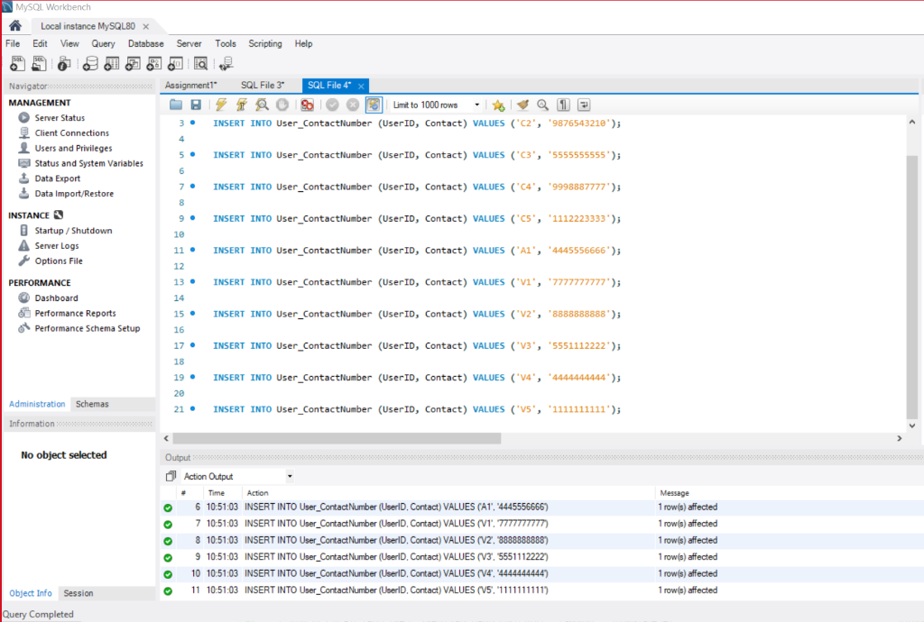

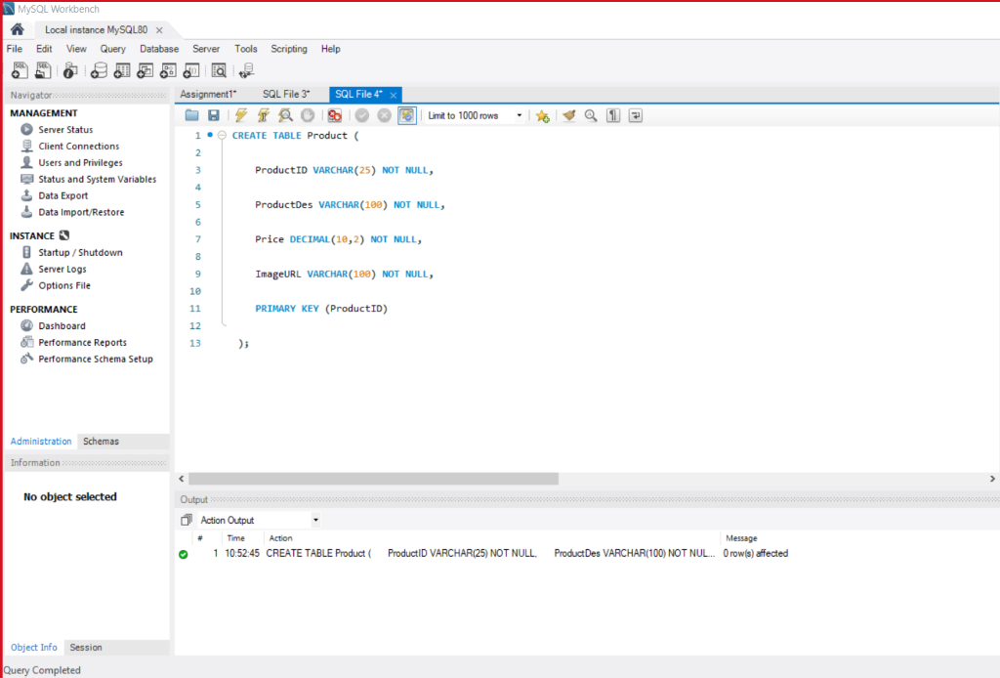

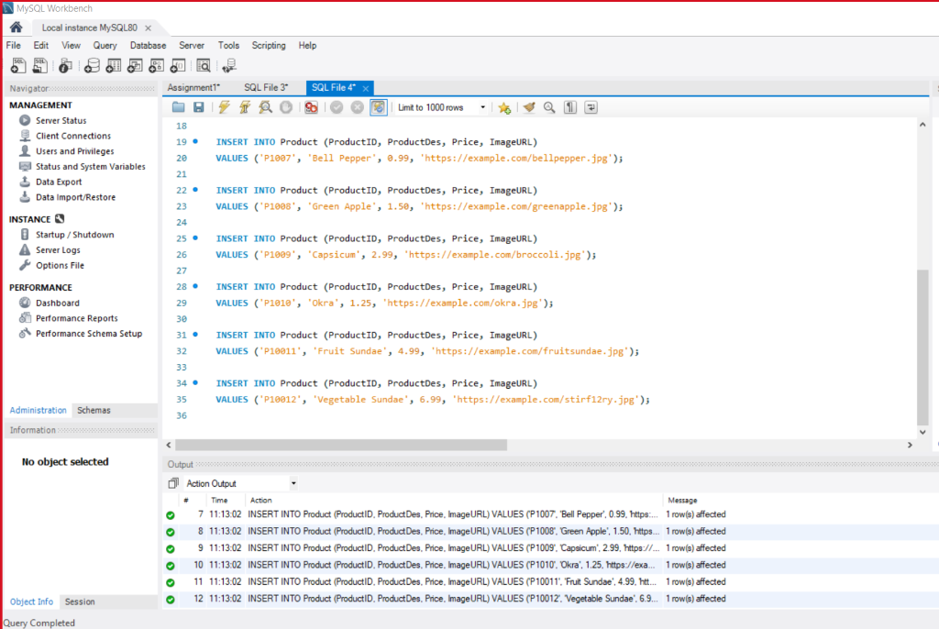

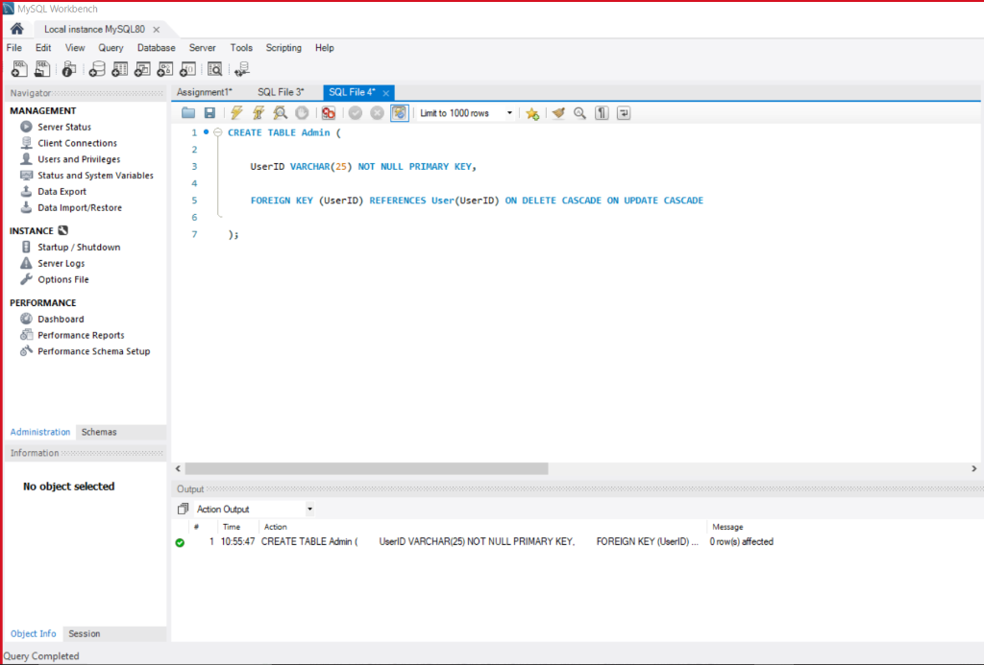

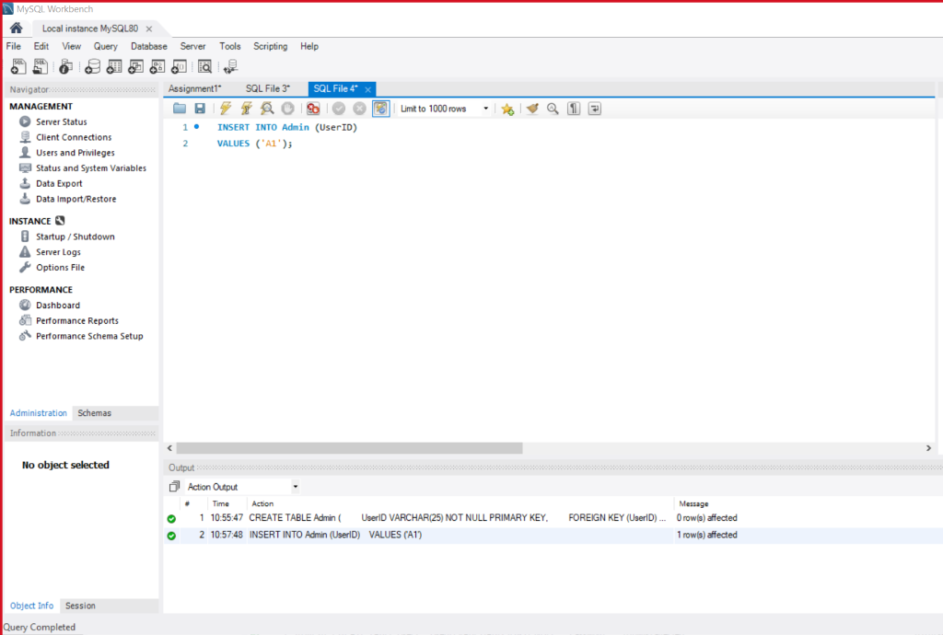

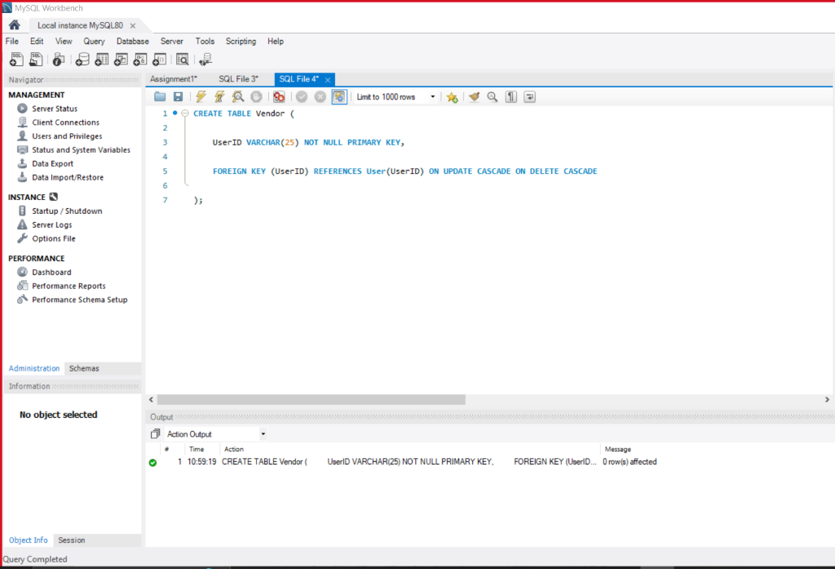

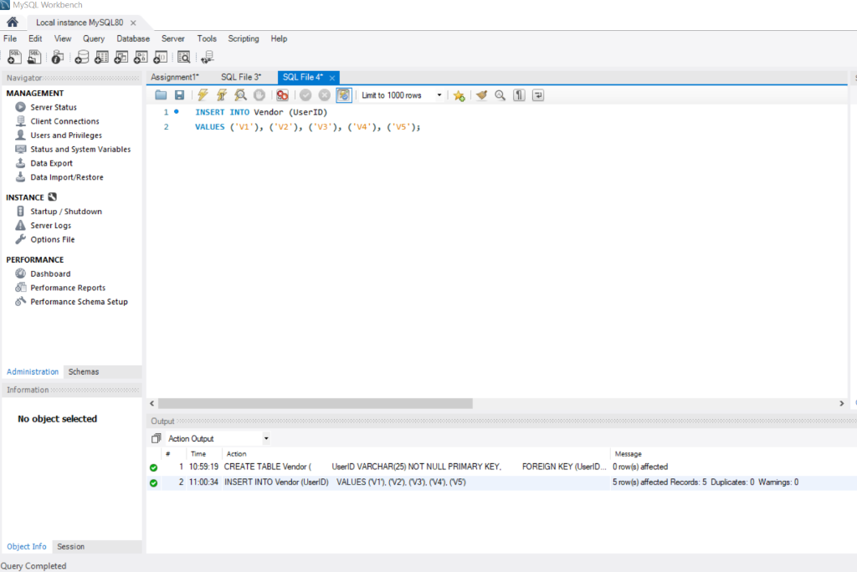

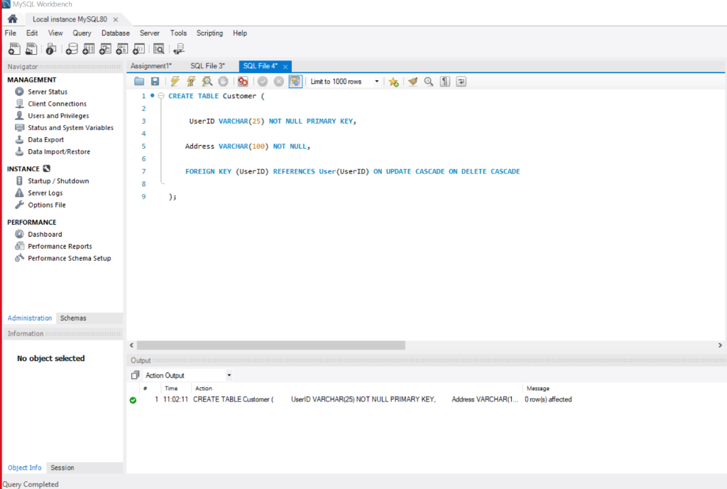

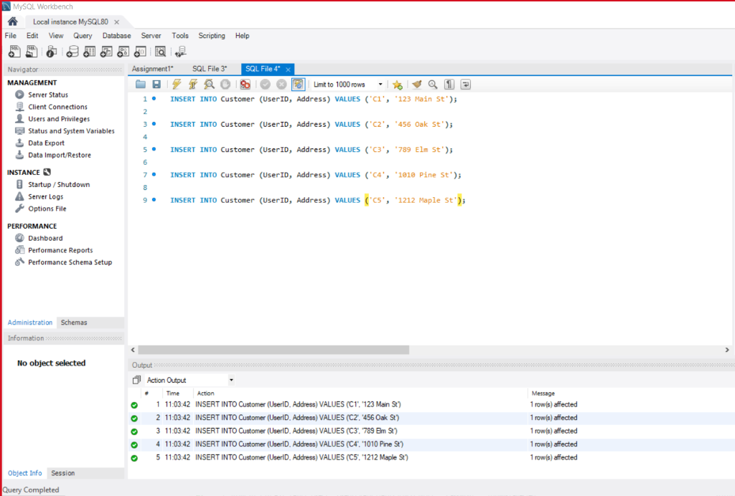

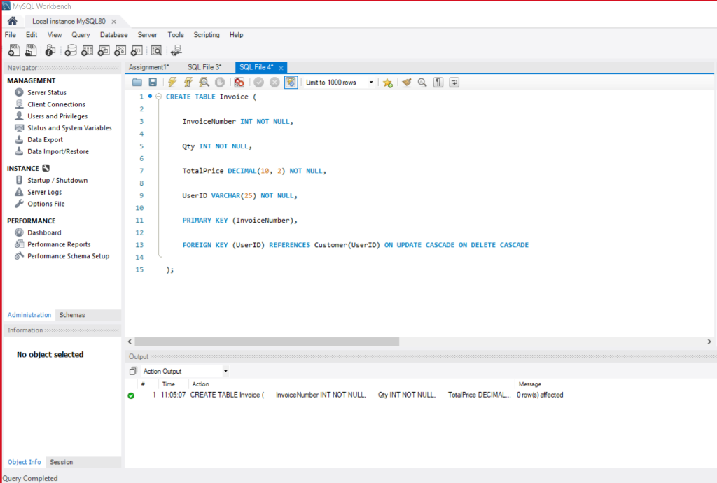

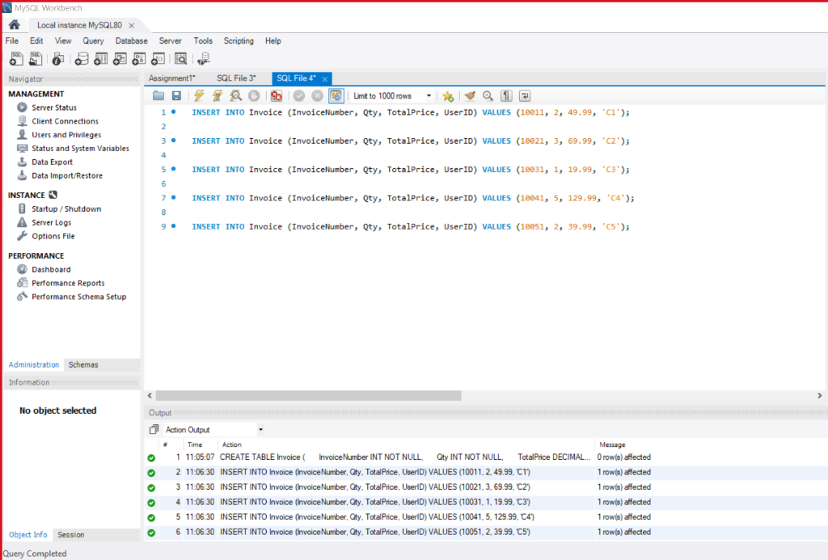

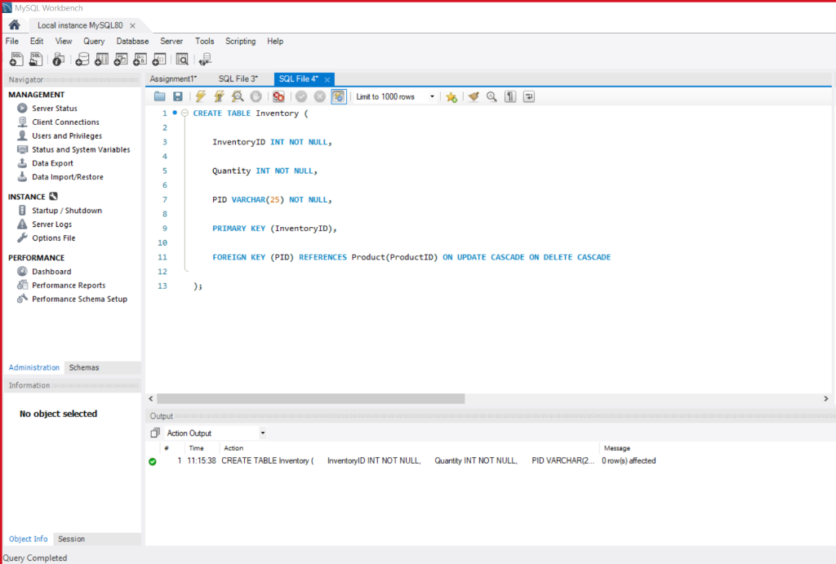

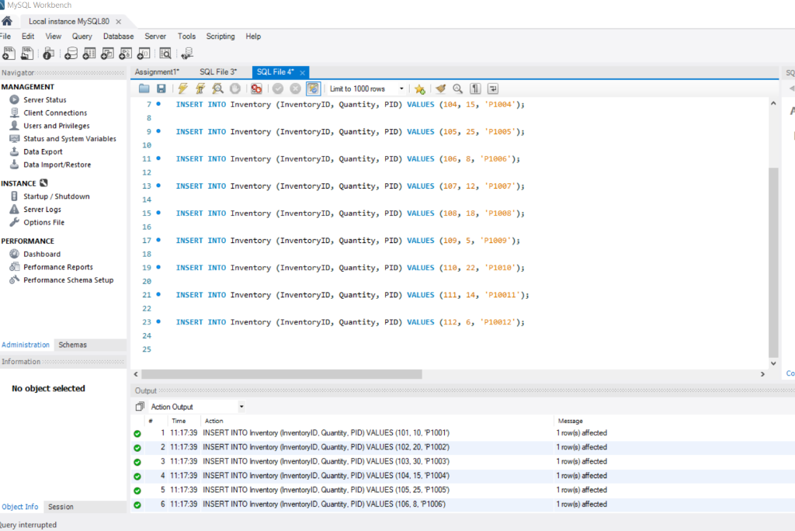

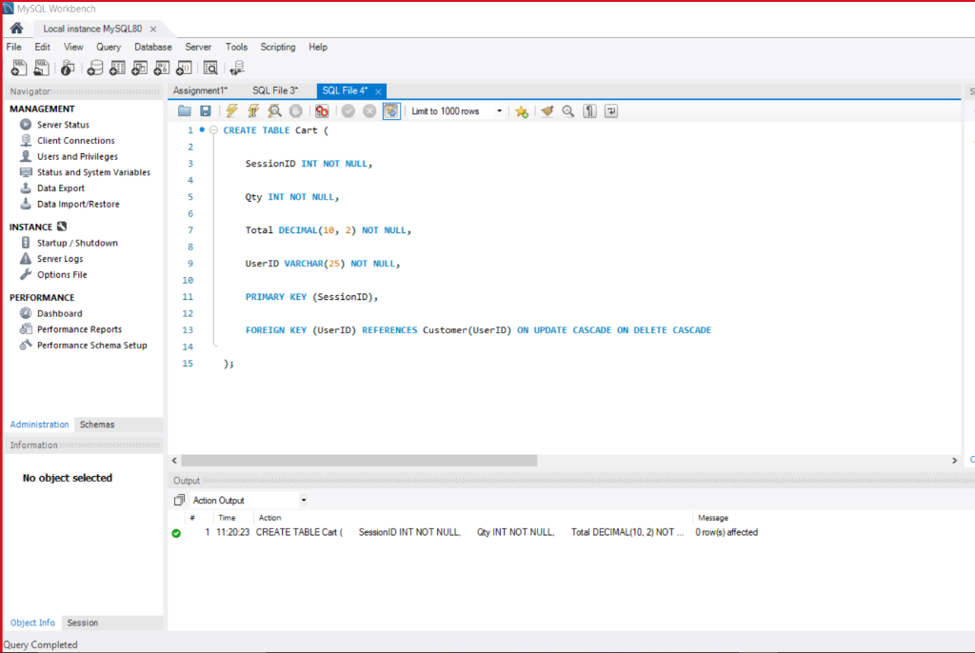

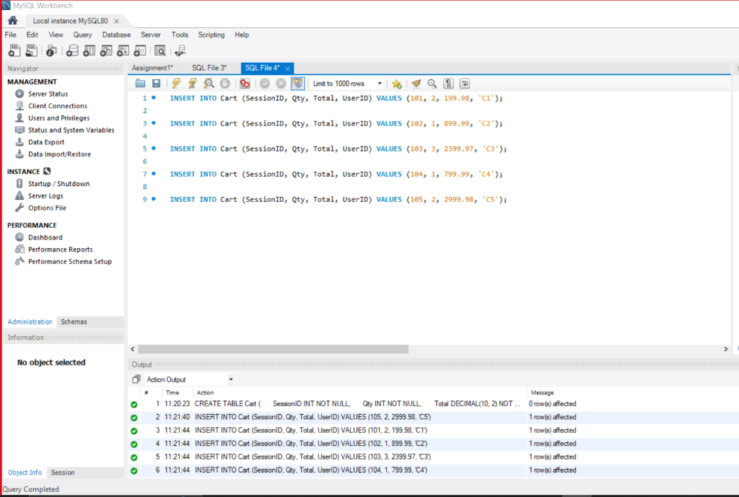

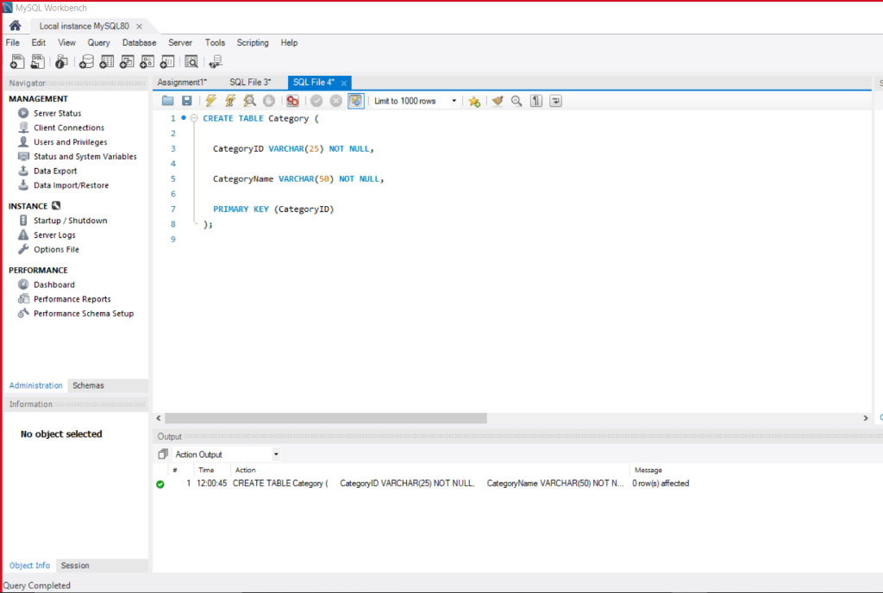



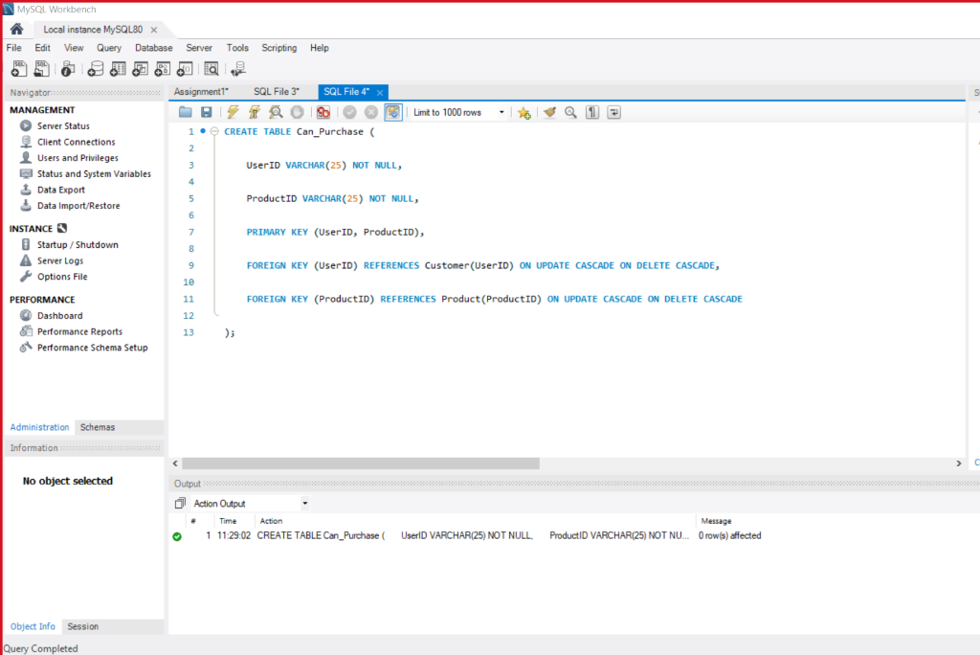

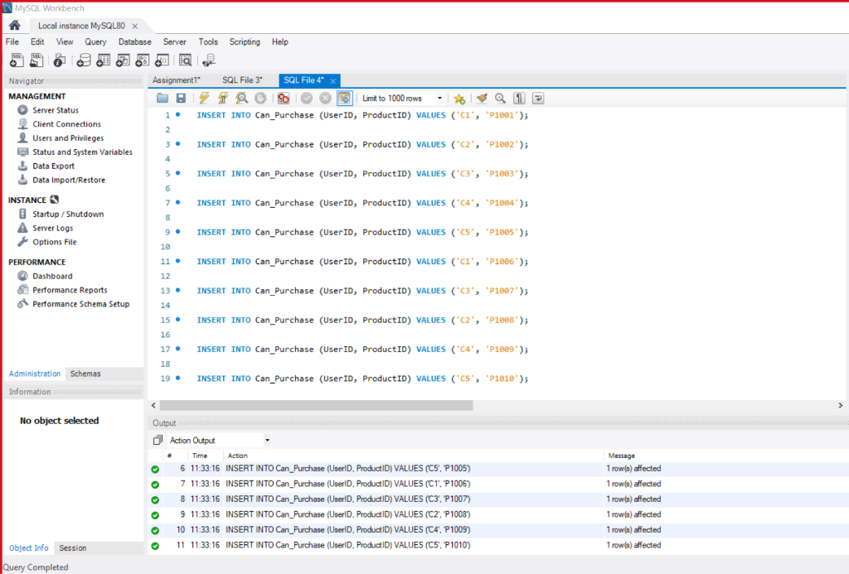

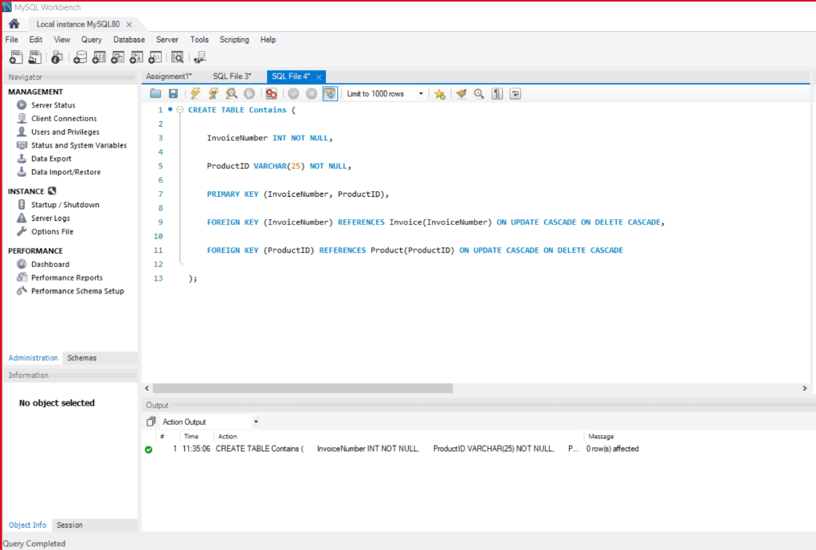

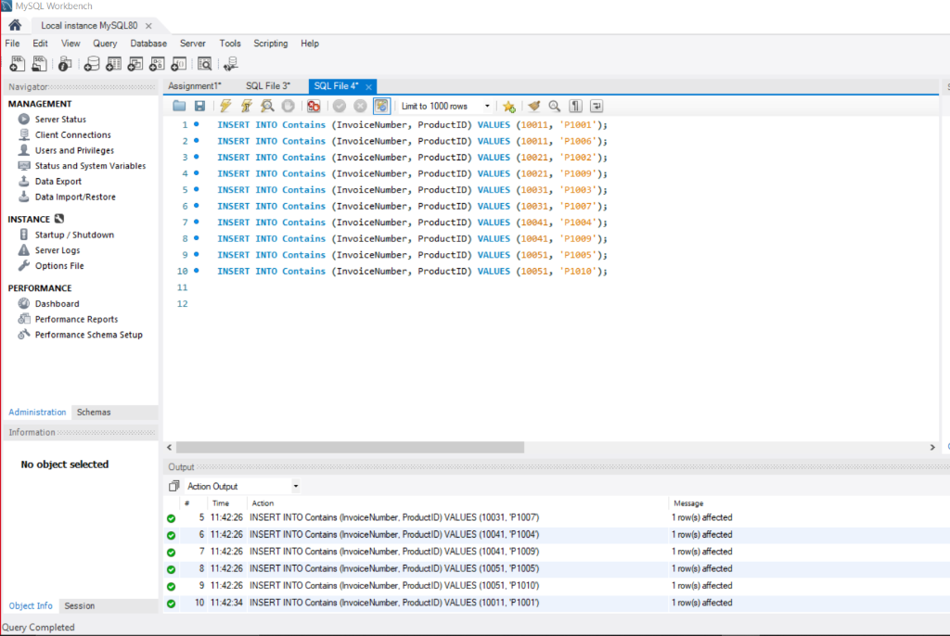

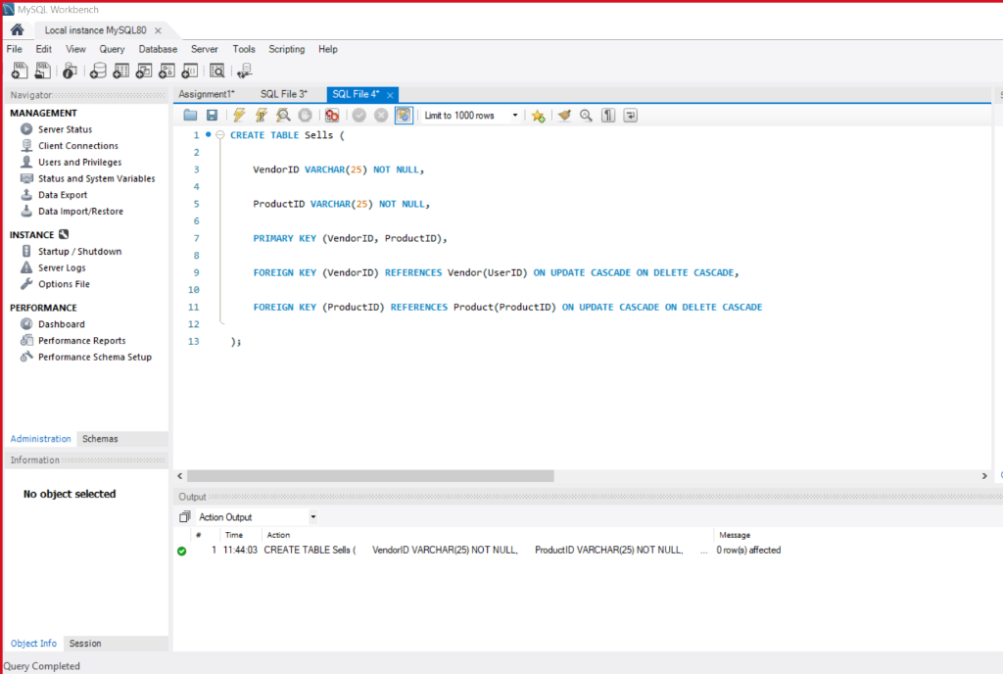

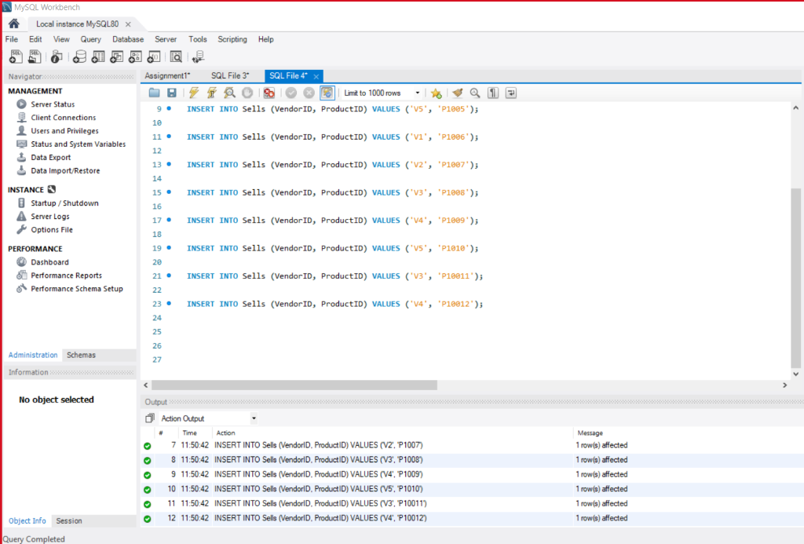

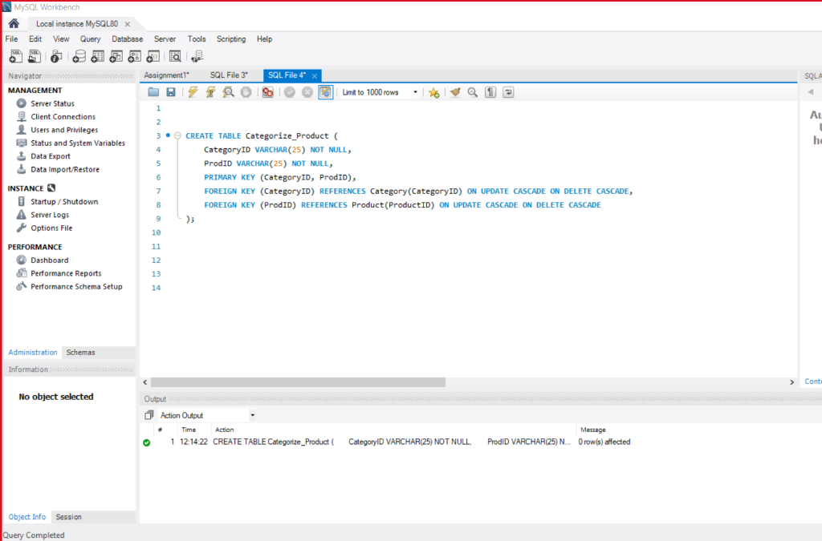

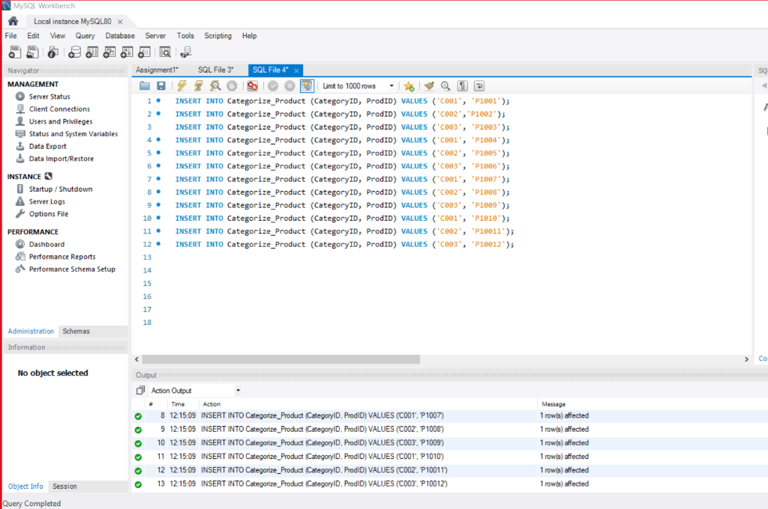

**Some Screen dumps of the operations above performed on the UTDFreshMart portal**

1. Initial login page for user : Admin / Customer / Vendor

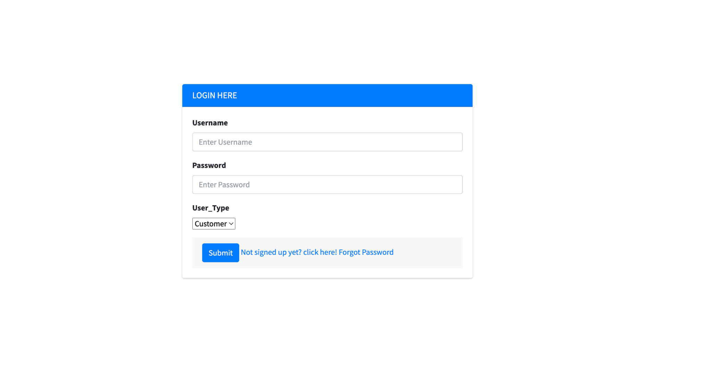

1. Admin view of dashboard after login :

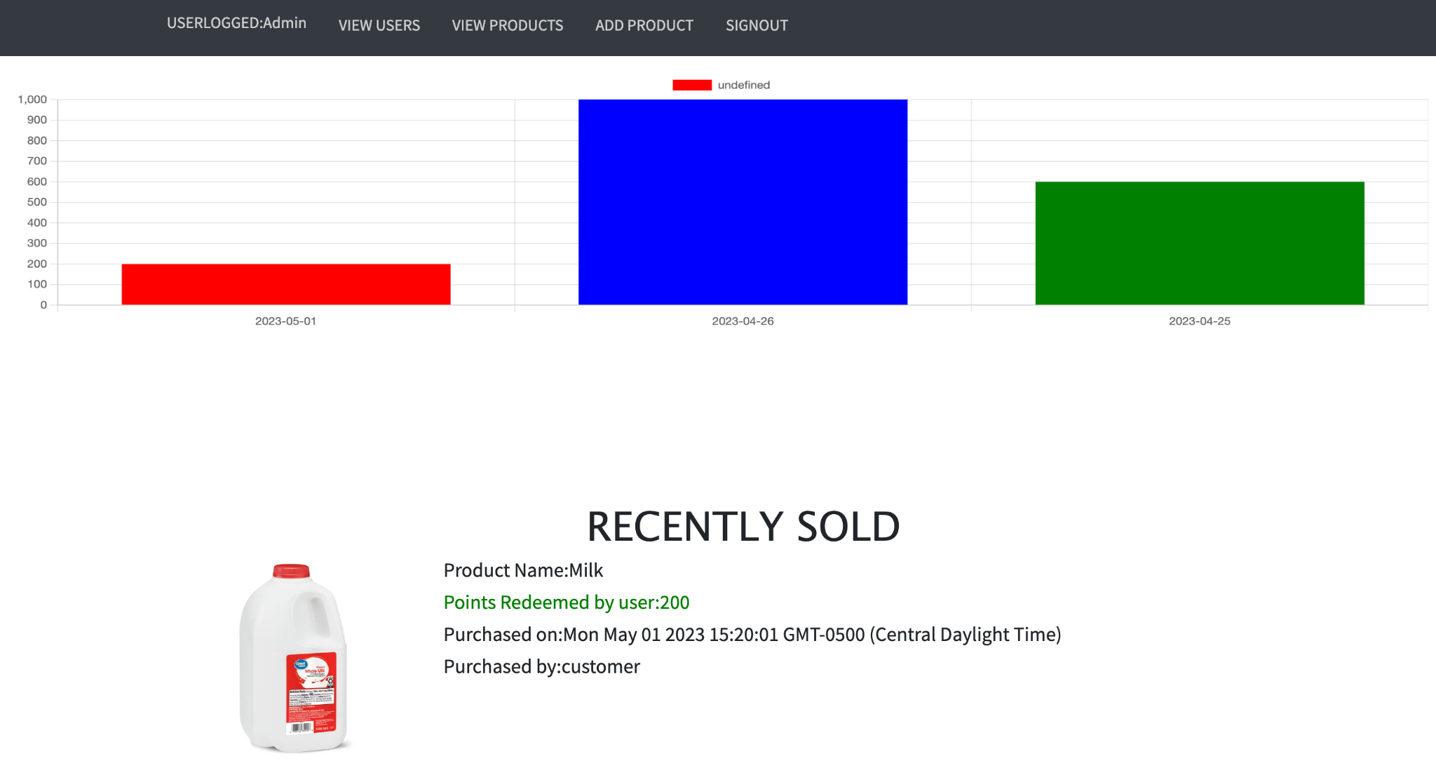

1. Admin manage user functionality :

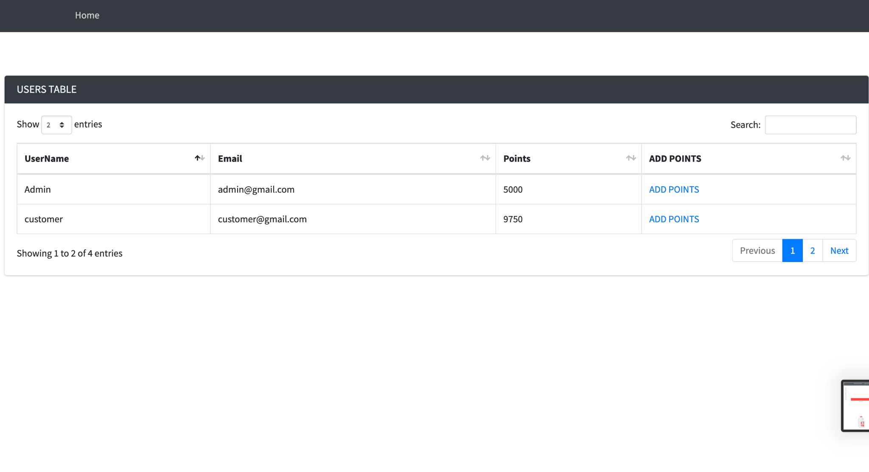

1. Admin / Vendor can add new products (insert into tables)   
   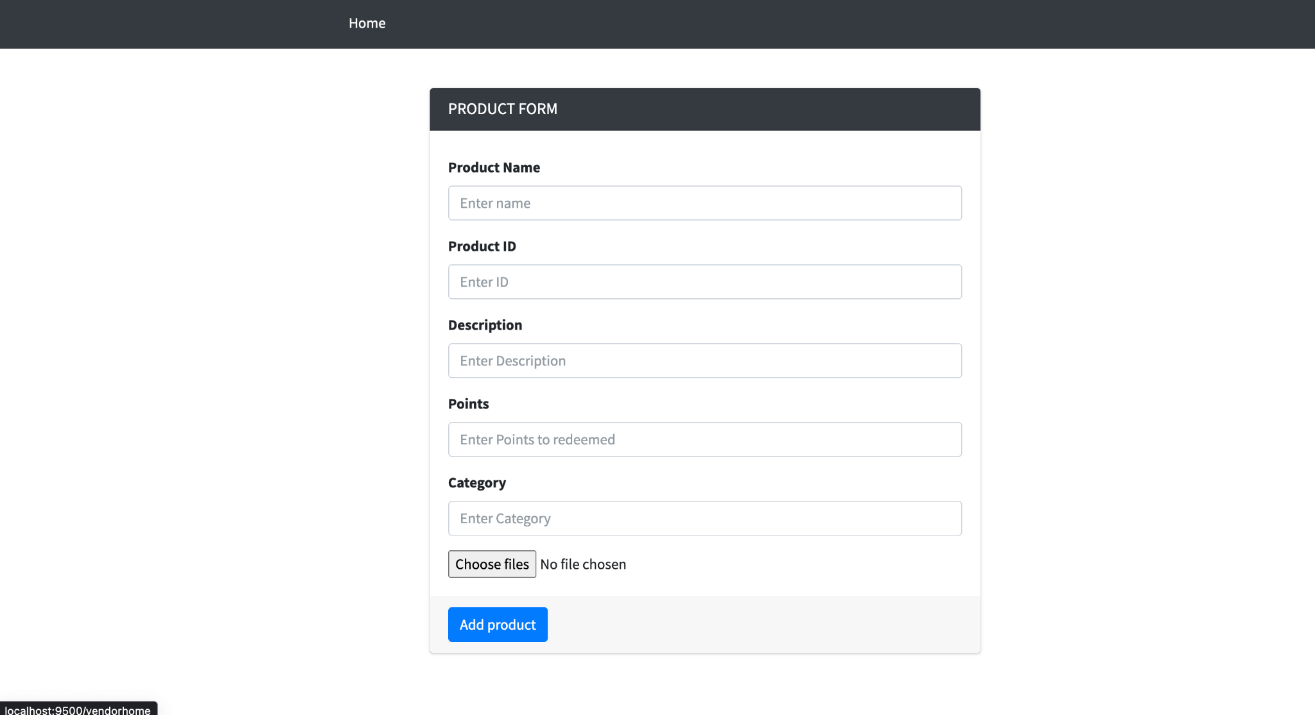

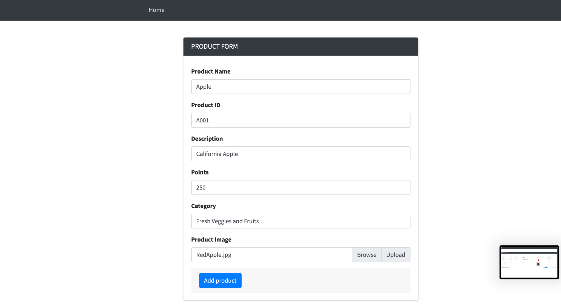

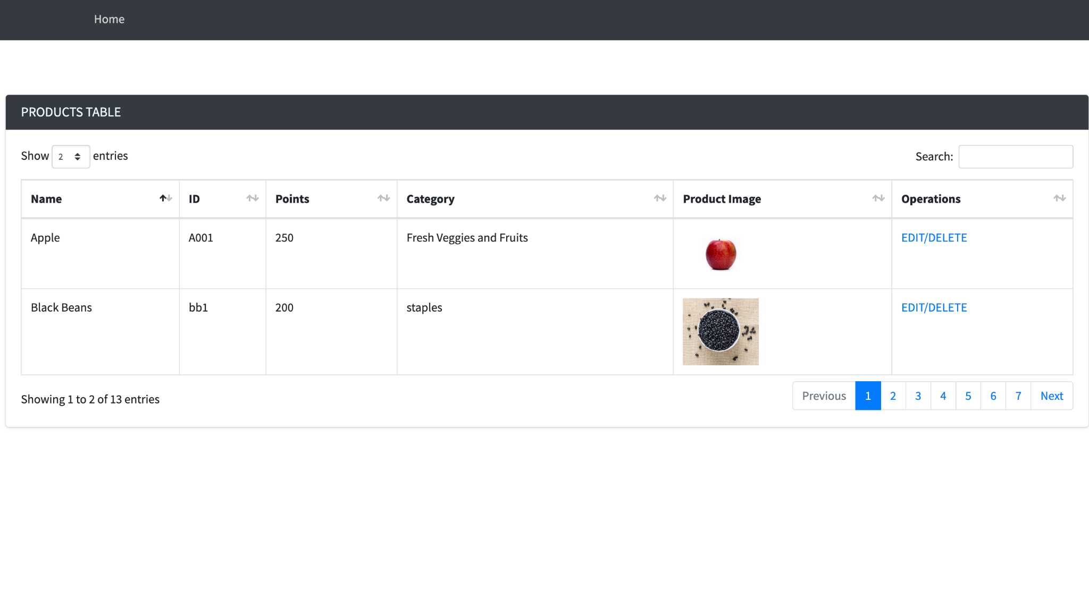

1. Vendor View of recently sold products sorted by date

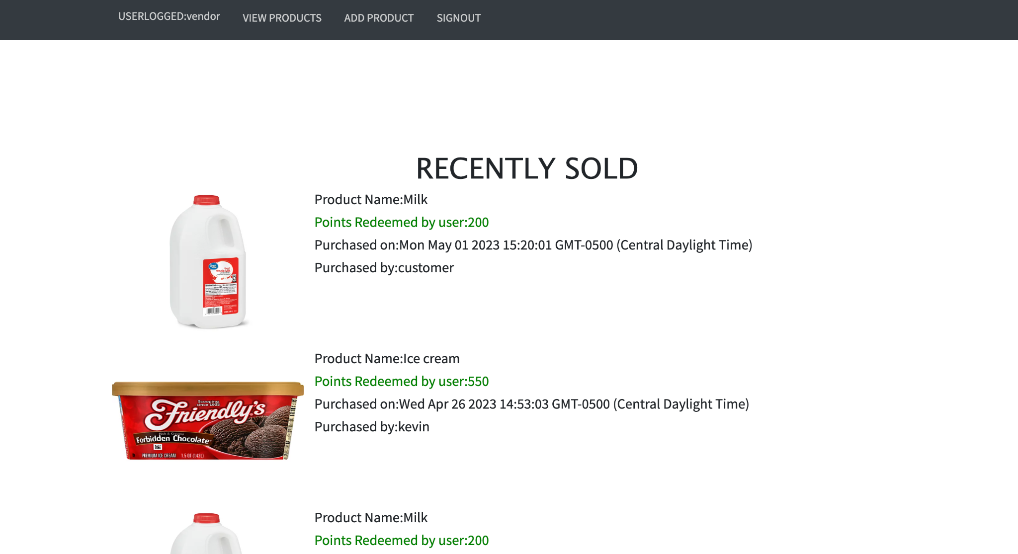

1. Customer homepage

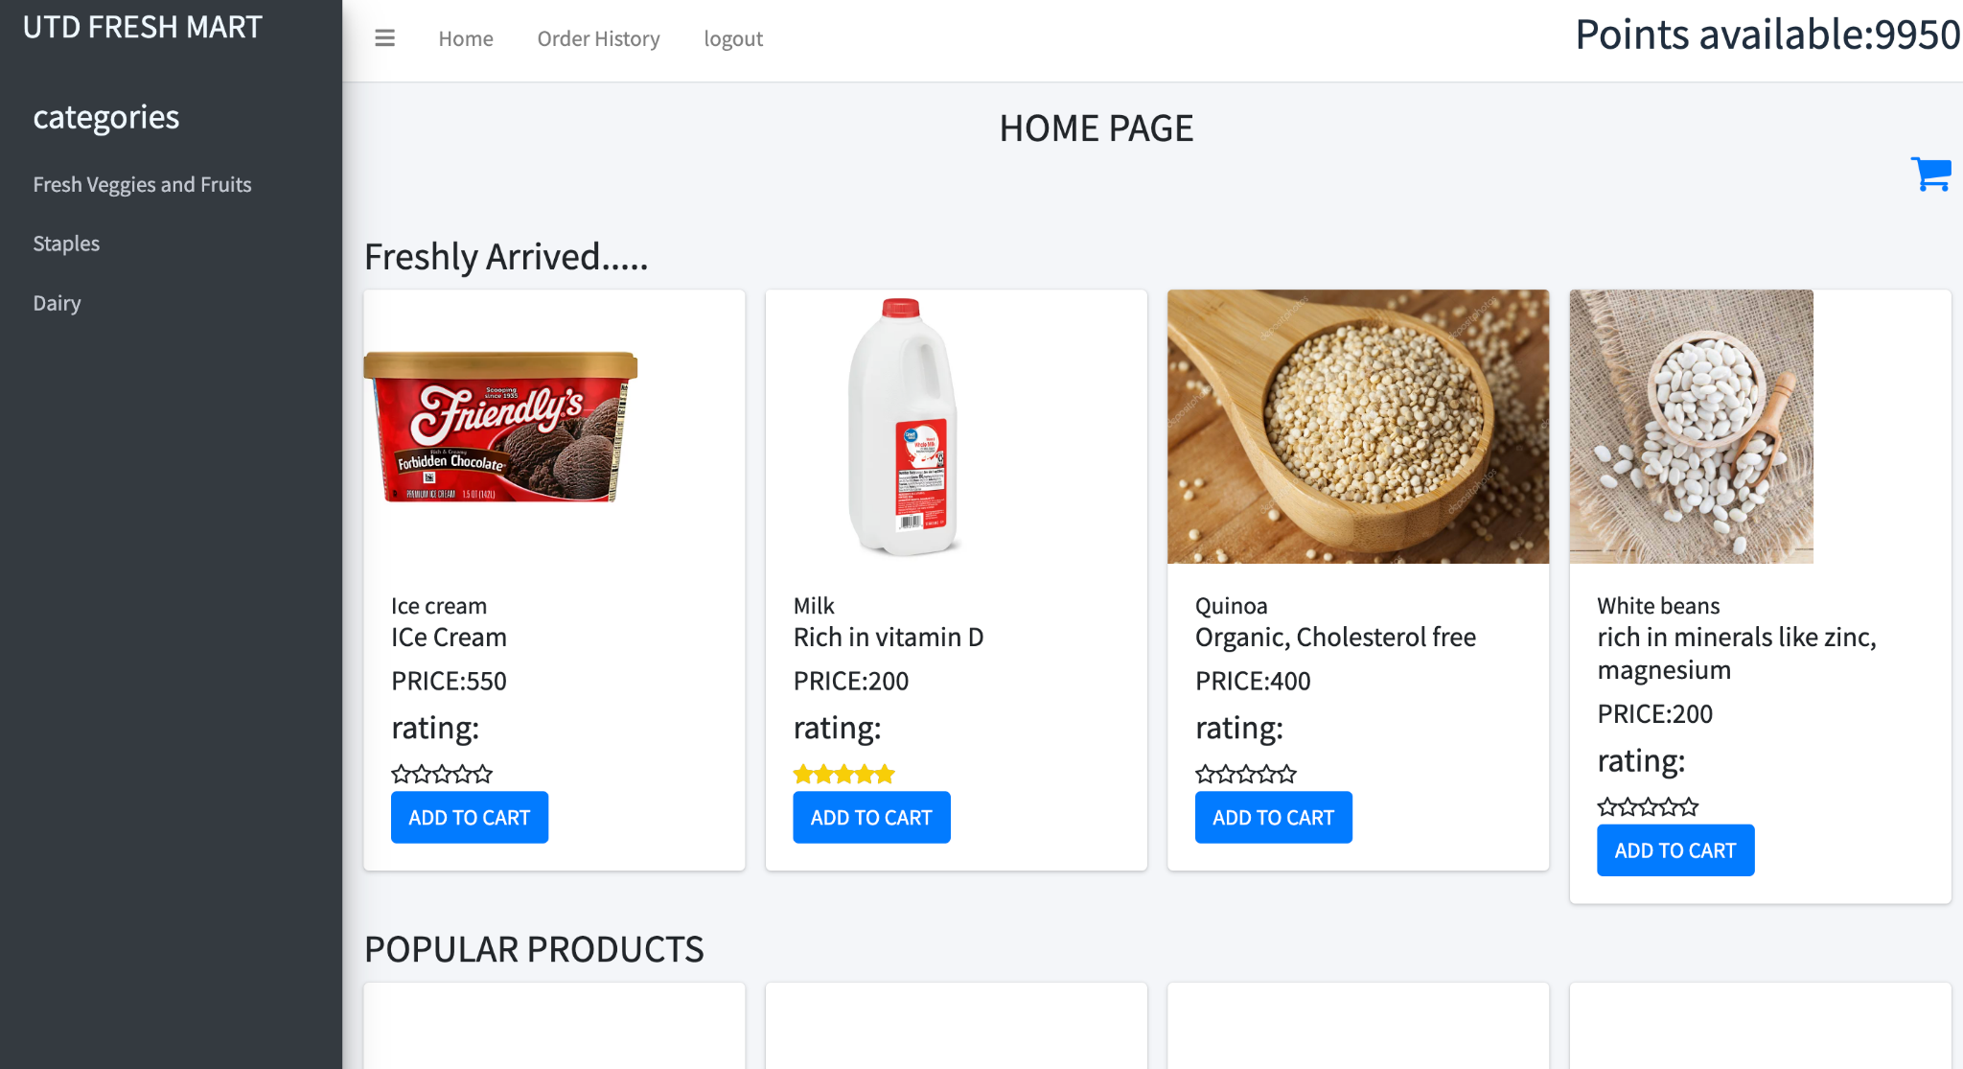

1. Customer Cart preview & Placing an order :

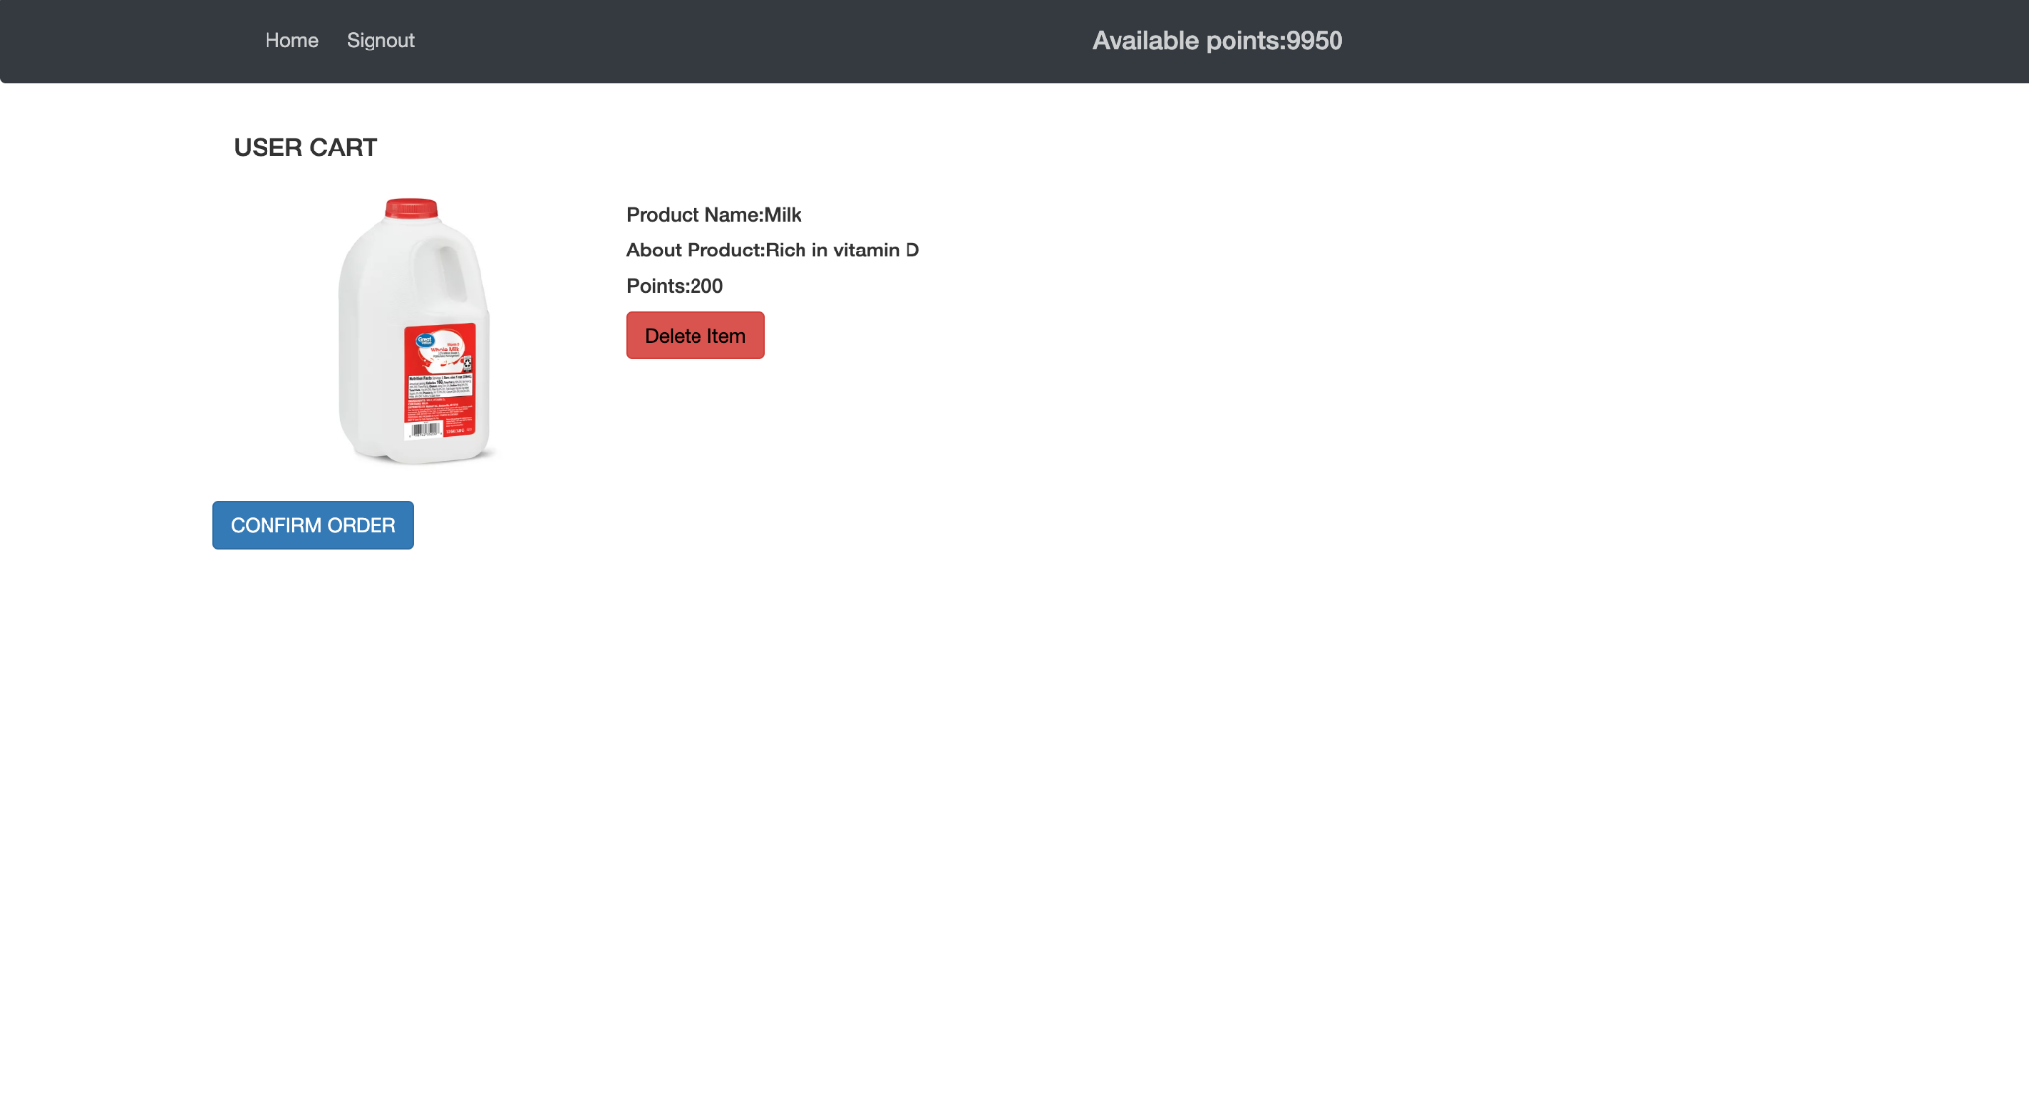

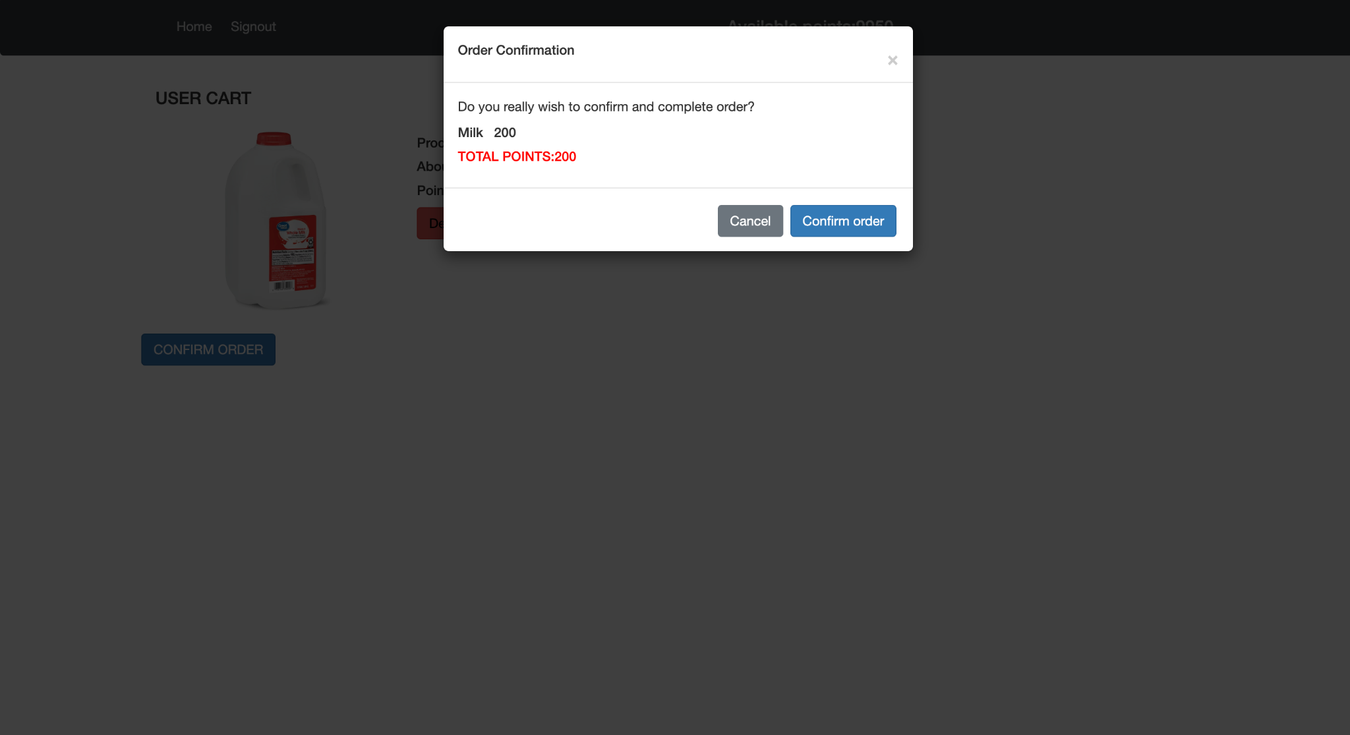

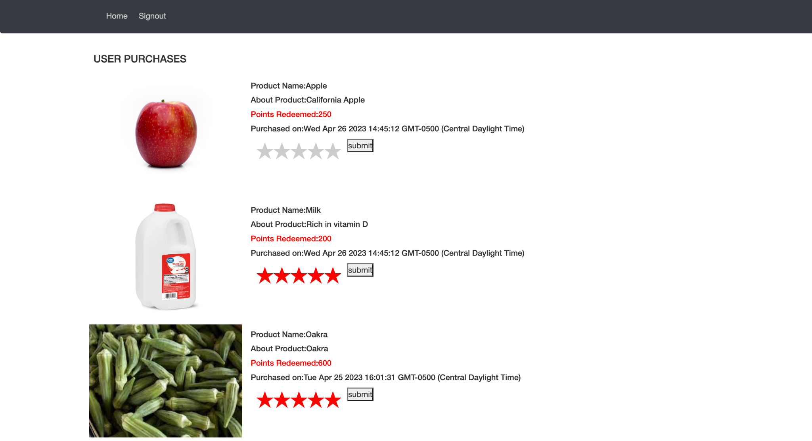

1. New User Creation :

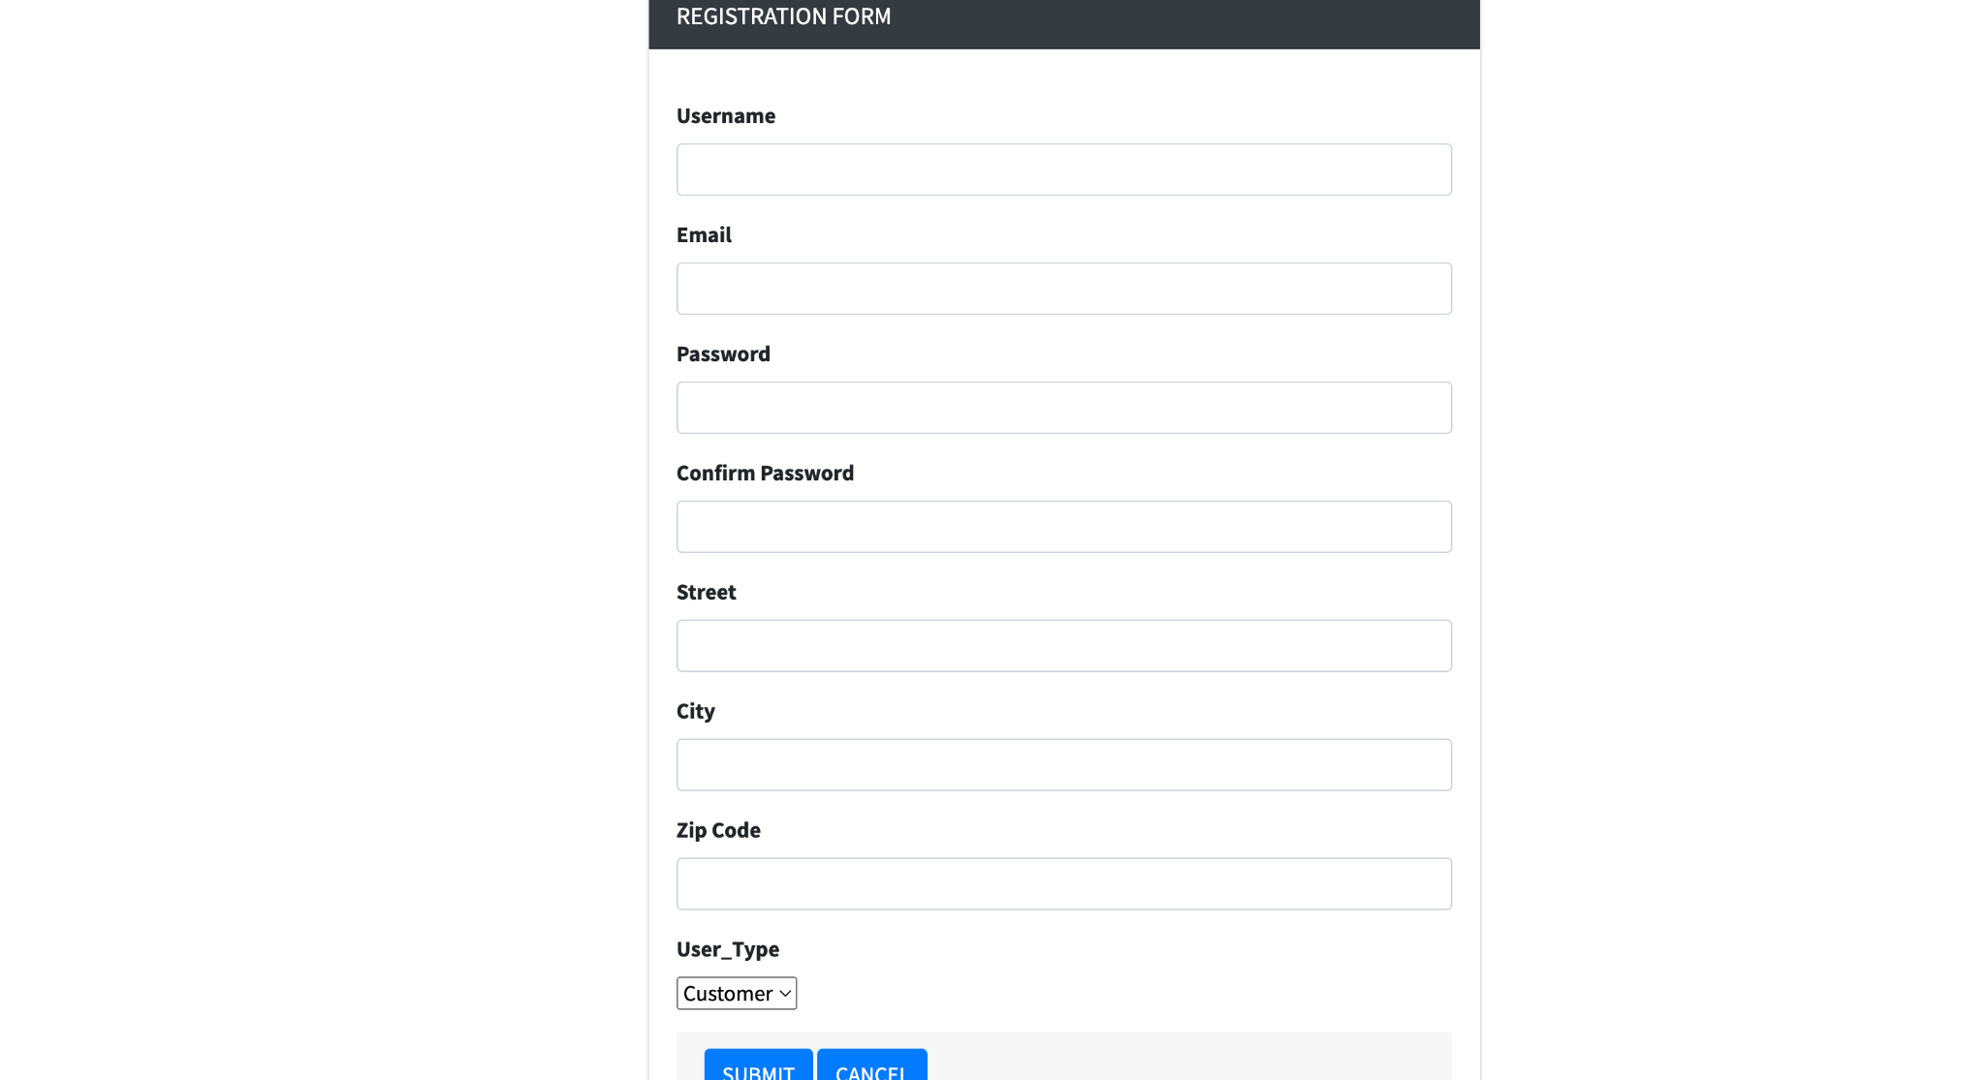

### **Additional Queries and Views**

**To Browse Products**

CREATE VIEW browse_products AS

SELECT ProductID, ImageURL, ProductDes, CategoryID, Price

FROM Product;

**To Track Inventory by products**

CREATE VIEW vendor_management AS

SELECT I Inventory,P ProductID ,P CategoryID, COUNT(P ProductID) AS products, SUM(I quantity * I price) AS total_value

FROM Inventory T1 LEFT JOIN Product T2

ON PID.T1 = ProductID.T2;

**To track the items sold by vendor**

CREATE VIEW as Vendor_Information

SELECT V UserID ,C CategoryName, S ProductID, P ProdDes,P Price, P ImageURL

From Vendor V

LEFT JOIN Sells S ON V.UserId = S.UserID

LEFT JOIN Products P ON S.ProdID = P.ProductID

LEFT JOIN Category C ON C.CategoryID = P.categoryID;

**To track all invoices of a Customer**

CREATE VIEW CustomerInvoices AS

SELECT c.UserID, c.Address, i.InvoiceNumber, i.Qty, i.TotalPrice

FROM Customer c

JOIN Invoice i ON c.UserID = i.UserID;

**To update the password of the User:**

UPDATE User_Password   
SET Password = 'new_password'   
WHERE UserID = 'C1';

**To update the contact number of the User:**

UPDATE User_ContactNumber

SET Contact = '3334445555'

WHERE UserID = 'C3';

**To update the price of the product**

UPDATE Product

SET Price = 1.2

WHERE ProductDes = 'P1001';

**To update the address of the User**

UPDATE User

SET Street = 'Cecil Dr', City = 'Plano', Zipcode = '75020'

WHERE UserID = 'C2';

**To update the quantity of the product**

UPDATE Inventory

SET Quantity = 400

WHERE PID = 'product_id';

### **User application interface**

1. The entire user interface was developed using Node JS.
2. The components of HTML, CSS, and Bootstrap were used to construct the front-end phase.
3. Each page is dynamically created using JavaScript controllers and the express framework, which also enables user interaction with the UI.
4. NodeJS routes are used to govern the data flow between the database and the user interface so that when the user requests anything from the database through the user interface, it responds appropriately.
5. A JWT (JSON Web Token) is generated and saved on the client side to be used during that session when a user logs into a web application. After the user logs out, the generated and cookie-stored token is removed.
6. After successfully validating his credentials, the user can utilize all the browsing/admin functions provided in the report's forepart, depending on whether they are administrators or not.

**BASIC FUNCTIONAL REQUIREMENTS PROVIDED ARE:**

**User Registration**

**User Login**

**Password Recovery**

**View/Edit/Add products into the inventory**

**View/Edit/Add personal details**

**Logout**

**PAGES:**

Home Page

Categories

Product Description Page

Cart Page

Order History

**FOR ADMIN:-**

1. View Data

2. Add Data

3. Edit Data

4. Delete Data

**FOR VENDOR:-**

1. View Data

2. Add Data

3. Edit Data

4. Delete Data

**FOR CUSTOMER: -**

1. View Data

**EXAMPLES OF HOW THE SOME ABOVE-MENTIONED FUNCTIONS PERFORMED IN SQL: -**

1. Registering the user in the database. **(For example, user is Technician)**

(‘INSERT INTO Customer (UserID, Address) VALUES (?, ?);’ - [UserID, Address]

(‘INSERT INTO Vendor (UserID) VALUES (?);’ - [UserID, Values])

(‘INSERT INTO Admin (UserID) VALUES (?);’ - [UserID, Values])

2. User Login **(Logging a user in based upon UserID and Password)**

(‘SELECT UserID, FirstName, LastName, Street, State, Zipcode, password FROM User WHERE Admin.UserID= ?;’, [UserID]);

3. Viewing Data from a page **(For example, to browse products)**

(‘SELECT ProductID, ImageURL, ProductDes, CategoryID, Price FROM Product;’)

4. Viewing Data from a page **(For example, to view products sold by a specific vendor)**

(‘SELECT V UserID ,C CategoryName, S ProductID, P ProdDes,P Price, P ImageURL From Vendor V’)

5. Adding Data into a page **(For example, Adding a new PRODUCT )**

(‘INSERT INTO Inventory (InventoryID, Quantity, PID) VALUES (?, ?, ?);’ - [InventoryID, Quantity, PID])

6. Updating data in a page **(For example, modifying a unique product’s price)**

(‘UPDATE Product SET Price = ? WHERE ProductDes = ?;’ - [Price, ProductDes])

7. Deleting Data from the page **(For example, deleting a product)**

(‘DELETE FROM Product WHERE PID = ?;', [PID])

### **Conclusions and Future Work**

### Conclusions:

### In conclusion, the project aims to establish an e-commerce platform for UTD FreshMart, a retailer of foodstuffs such as fruits, vegetables, snacks, and other household items.

### Customers will have an easy and effective way to buy things online using the platform, and sellers will be able to add and manage their inventory.

### An administrator will also be in charge of the platform's general operations, such as vendor management and transaction monitoring.

### Login functionality, browsing functionality, and vendor functionality are among the platform's functional needs.

### Security, scalability, performance, usability, dependability, integration, accessibility, data backup and management, compliance, customization, technical support, inventory management, and user feedback are examples of the platform’s non-functional needs.

### Future Work:

### This e-commerce platform has a number of areas that could be developed further in the future.Incorporating more sophisticated machine learning and data analysis methods to improve the platform's product recommendation system may be one area of future work. By recommending goods that are more appropriate for customer preferences could enhance the user experience.

### Adding other payment gateways to provide clients more options for making payments could be another area of future effort. Support for mobile payments, cryptocurrency, or other cutting-edge payment systems fall under this category.

### In order to appeal to a wider spectrum of clients, the platform might also be expanded to incorporate new product categories, such as apparel or electronics.

### Finally, adding more social features like user reviews, ratings, and sharing capabilities could increase platform users' engagement.

### **References**

1. Fundamentals of Database Systems, 7th Edition, R. Elmasri and S. B. Navathe, Addison-Wesley. ISBN-13: 978-0133970777.
2. Database System Concepts, 7th Edition, By Avi Silberschatz, Henry F. Korth and S. Sudarshan. McGraw-Hill, ISBN 9780078022159.

### **Appendix**

1. Source code for project : <https://github.com/savyasachirao/project>